Teacher Guide to Clarification

**1.NBT.6**

**Use place value understanding and properties of operations to add and subtract.**

**1.NBT.6** Subtract multiples of 10 in the range 10-90 from multiples of 10 in the range of 10-90 (positive or zero differences), using concrete model or drawings and **strategies based on place value, properties of operations, and/or the relationship between addition and subtraction**; relate the strategy to a written method and explain the reasoning used.

**Strategies based on Place Value & Properties of Operations**

Place value strategies, counting strategies, and properties of operations help us to fluently add and subtract.

Example: There are 60 students in the gym. 30 students leave. How many students are still in the gym?

Student 1: I used a hundreds chart and started at 60. I moved up 3 rows to land on 30. There are 30 students left.

Student 2: I used place value blocks or unifix cubes to build towers of 10. I started with 6 towered of 10 and removed 3. Had 3 towers left. 3 towers have a value of 30. There are 30 students left.

Student 3: Students mentally apply their knowledge of addition to solve this subtraction problem. I know that 30 plus 30 is 60, so 60 minus 30 equals 30. There are 30 students left.

Student 4: I used a number line. I started at 60 and moved back 3 jumps of 10 and landed on 30. There are 30 students left.

Students may use interactive versions of models (base ten blocks, 100s charts, number lines, etc.) to demonstrate and justify their thinking.

Math Practice 5 - Use appropriate tools strategically.

In early grades, students experiment with representing problem situations in multiple ways including using objects, drawing pictures, words using mathematical language, and numbers to create equations. Students need opportunities to connect the different representations and explain the connections. They should be able to use any of these representations as needed.

**Math Practice 8** Look for and express regularity in repeated reasoning connects nicely to this standard because in the early grades, students notice repetitive actions in counting and computation. When children have multiple opportunities to add and subtract “ten” and multiples of “ten” they notice the pattern and gain a better understanding of place value. Students continually check their work by asking themselves, “Does this make sense?” The properties of operations are a reliable anchor for reasoning; they hold for whole numbers, and deep understanding of the properties will help with reasoning of rational numbers, real numbers, complex numbers and eventually variables.

Kansas Association of Teachers of Mathematics (KATM) Flipbooks. Questions or to send feedback: [melisa@ksu.edu](mailto:melisa@ksu.edu). Retrieved from: <http://katm.org/wp/wp-content/uploads/flipbooks/4FlipBookedited.pdf>

**Coherence and Connections: Need to Know**

|  |  |  |
| --- | --- | --- |
| Grade Below | Grade-Level | Grade Above |
| None | **1.NBT.6** 1.NBT.2 | 2.OA.1 2.NBT.5 |

**1.NBT.C.6 depends on the Fluency Expectations of 1.NBT.C.5** Given a two-digit number, mentally find 10 more or 10 less than the number, without having to count; explain the reasoning used. Quickly finding 10 more or 10 less than a two-digit number is best thought of as an indicator of whether students have an understanding of place value for two-digit numbers.

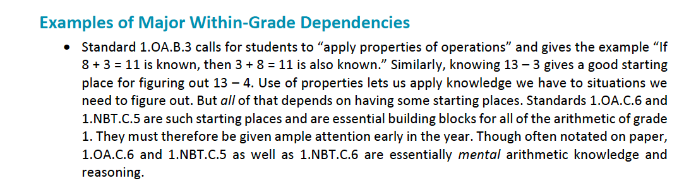

*PARCC Draft Model Content Frameworks: Mathematics Grades K-2* (2013, December).  
 Retrieved May 10, 2014, from <http://parcconline.org/sites/parcc/files/PARCCMCFMathematicsNovember2012V3_FINAL_0.pdf>

Use the PowerPoint to have discussions about how students think

**Classroom Resources**

PARCC Draft Grade 1 Formative Task Prototype

<http://parcconline.org/sites/parcc/files/PARCC%20DRAFT%20K-1%20Prototype%20Mathematics%20Task%20-%20Adding%20and%20Subtracting%201%20and%2010.pdf>

Use the number line to show 70 -20 = 50

0 10 20 30 40 50 60 70 80 90 100

Use the open number line as a tool for counting on and counting backwards.

Solve the following equations on the number line.

70 – 40 =

**Hot Questions**

1. Davon was solving subtraction problems, and he solved the problems like this:

Write the subtraction problem that Davon was solving.

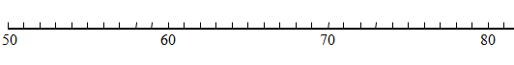

a.

b.



c.

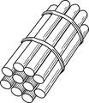



1. True or False: When you subtract zero the answer is always zero.
2. You spent 50 cents at the store.

What did you buy if you bought 2 things? What did you buy if you bought 3 things? What did you buy if you bought 4 things? What did you buy if you bought 5 things?

Show your answers with subtraction equations.

|  |  |  |  |
| --- | --- | --- | --- |
| **C:\Users\scabreda\AppData\Local\Microsoft\Windows\Temporary Internet Files\Content.IE5\Z98B4X2H\MC900237619[1].wmf**  **Pencil**  **10¢** | **C:\Users\scabreda\AppData\Local\Microsoft\Windows\Temporary Internet Files\Content.IE5\U0JCL14M\MC900232926[1].wmf**  **Eraser**  **10¢** | **C:\Users\scabreda\AppData\Local\Microsoft\Windows\Temporary Internet Files\Content.IE5\Z188IB0B\MC900295063[1].wmf**  **Pencil Sharpener**  **20¢** | **C:\Users\scabreda\AppData\Local\Microsoft\Windows\Temporary Internet Files\Content.IE5\Z98B4X2H\MC900232724[1].wmf**  **Box of Crayons**  **30¢** |

**Additional Resources**

Dana Center  
<http://www.utdanacenter.org/ccss/early_math.php>

Hawaii DOE  
<http://standardstoolkit.k12.hi.us/going-to-the-store-1-nbt-11-nbt-41-nbt-6/>

Oregon City School District Worksheet  
<http://www.orecity.k12.or.us/files/1st_Grade_1.6_Multiples_of_10.pdf>

Howard County Wikispace  
<https://grade1commoncoremath.wikispaces.hcpss.org/Assessing+1.NBT.6>

Brain Pop  
<http://www.brainpop.com/educators/community/bp-jr-topic/adding-and-subtracting-tens/>