Teacher Guide to Clarification
1. OA. 1

Represent and solve problems involving addition and subtraction.
1.OA.1 Use addition and subtraction within 20 to solve word problems involving situations of adding to, taking from, putting together, taking apart, and comparing, with unknowns in all positions, e.g., by using objects, drawings, and equations with a symbol for the unknown number to represent the problem.
With Unknowns in All Positions

(CCSS Glossary, Table 1). There are three types of addition and subtraction problems: Result Unknown, Change Unknown, and Start Unknown.
Examples:
Result Unknown | Change Unknown | Start Unknown
There are 9 students on the playground. Then 8 more students showed up. How many students are there now?  9 + 8 = ______ | There are 9 students on the playground. Some more students showed up. There are now 17 students. How many students came?  9 + _____ = 17 | Here are some students on the playground. Then 8 more students came. There are now 17 students. How many students were on the playground at the beginning?  _____ + 8 = 17

Use the addition symbol (+) to represent joining situations, the subtraction symbol (-) to represent separating situations, and the equal sign (=) to represent a relationship regarding quantity between one side of the equation and the other.
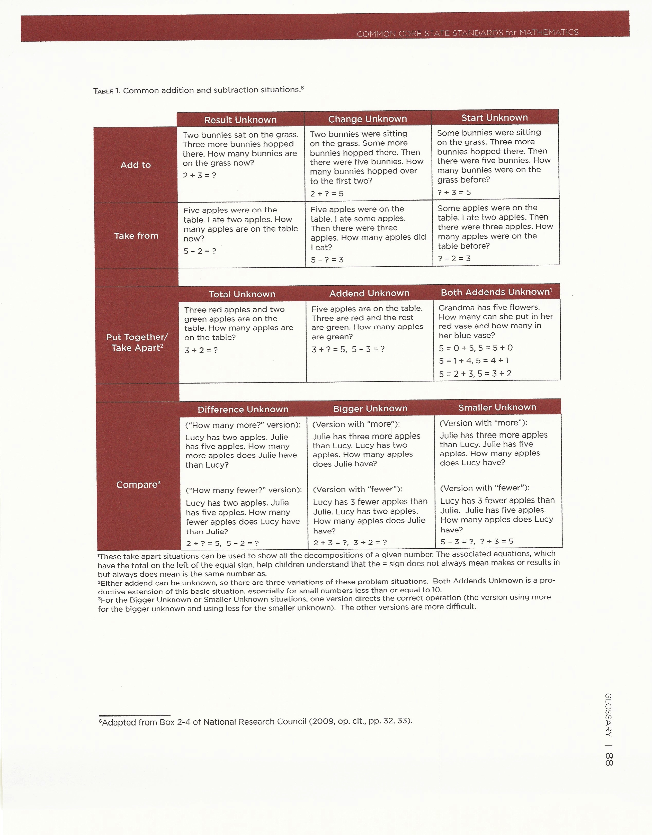
The study of word problems in grade 1 (1.OA.A.1, 1.OA.A.2) can be coordinated with students’ growing proficiency with addition and subtraction within 20 (1.OA.C.6) and their growing. Word problems can also be linked to students’ growing understanding of properties of addition and the relationship between addition and subtraction. For example, put together/take apart problems with addend unknown can show subtraction as finding an unknown addend.
Common Core Standards Writing Team. (2013, September 19). Progressions for the Common
Core State Standards in Mathematics(draft). K-5 Counting and Cardinality and
Operations and Algebraic Thinking. Tucson, AZ: Institute for Mathematics and
Educations, University of Arizona.

proficiency with multidigit addition and subtraction (1.NBT).9

Coherence and Connections: Need to Know
Grade Below | Grade-Level | Grade Above
K.OA.2 | 1.OA.1  1.OA.2  1.MD.4  1.OA.8  1.OA.6 | 2.OA.1

Connections: This cluster is connected to the First Grade Area of Focus #1, Developing understanding of addition, subtraction, and strategies for addition and subtraction within 20. This cluster is connected to Understand addition as putting together and adding to, and understand subtraction as taking apart and taking from in Kindergarten, to Work with addition and subtraction equations in Grade 1, and to Represent and solve problems involving addition and subtraction and Add and subtract within 20 in Grade 2.
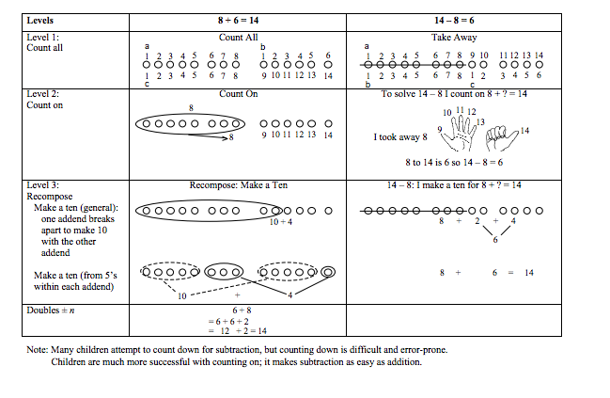
Common Core Standards Writing Team. (2013, September 19). Progressions for the Common
Core State Standards in Mathematics(draft). K-5 Counting and Cardinality and
Operations and Algebraic Thinking. Tucson, AZ: Institute for Mathematics and
Educations, University of Arizona.

Classroom Resources

PowerPoint
Problem of the Day- Every day start with a number story from http://sdesa.k12.sd.us/esa5/docs/sdcounts/SDCountsMathProblemBooklet.pdf
Make sure you choose a variety of
- problems with the Result Unknown,
- problems with a Change Unknown,
- problems with a Start Unknown.
Literature is a great connection and fun way to incorporate problem solving in real world context.
http://www.mathstart.net/

http://parcconline.org/sites/parcc/files/PARCC%20DRAFT%20K-1%20Prototype%20Mathematics%20Task%20-%20Word%20Problems.pdf
Hot Questions
- 6 baby bears played tag. Some bears were tagged out of the game. 2 bears were left to play the rest of the game. How many bears were tagged out? Solve using a number bond and equation.

=

_______ _______ _______

PARCC Draft Grade 1 Formative Task Prototype Word Problems
http://parcconline.org/sites/parcc/files/PARCC%20DRAFT%20K-1%20Prototype%20Mathematics%20Task%20-%20Word%20Problems.pdf

Additional Resources

Illustrative Mathematics
https://www.illustrativemathematics.org/illustrations/160
https://www.illustrativemathematics.org/illustrations/161
https://www.illustrativemathematics.org/illustrations/162
https://www.illustrativemathematics.org/illustrations/163
https://www.illustrativemathematics.org/illustrations/194
https://www.illustrativemathematics.org/illustrations/195
https://www.illustrativemathematics.org/illustrations/196
https://www.illustrativemathematics.org/illustrations/197
https://www.illustrativemathematics.org/illustrations/1152
https://www.illustrativemathematics.org/illustrations/1317
https://www.illustrativemathematics.org/illustrations/2
https://www.illustrativemathematics.org/illustrations/1650
https://www.illustrativemathematics.org/illustrations/981
https://www.illustrativemathematics.org/illustrations/1086
Howard County Wikispace (links at bottom of the page)
https://grade1commoncoremath.wikispaces.hcpss.org/1.OA.1
Hawaii Tasks
http://standardstoolkit.k12.hi.us/children-on-the-bunk-bed-1-oa-1/
http://standardstoolkit.k12.hi.us/how-many-fingers-1-oa-11-nbt-11-nbt-4/
http://standardstoolkit.k12.hi.us/how-many-flowers-1-oa-11-nbt-11-nbt-4/
http://standardstoolkit.k12.hi.us/how-many-pencils-1-oa-11-nbt-11-nbt-6/
http://standardstoolkit.k12.hi.us/lets-share-markers-1-oa-1/
http://standardstoolkit.k12.hi.us/making-leis-1-oa-1/
http://standardstoolkit.k12.hi.us/shopping-for-school-supplies-1-oa-1/
http://standardstoolkit.k12.hi.us/students-in-the-class-1-oa-1/

