Teacher Guide to Clarification

**1.OA.2**

**Represent and solve problems involving addition and subtraction**

1.OA.2Solve word problems that call for addition of three whole numbers whose sum is less than or equal to 20, e.g., by using objects, drawings, and equations with a symbol for the unknown number to represent the problem.

**Addition of Three Whole Numbers**

At this grade level students are developing understandings of addition and strategies for addition within 20. Students will be combining numbers through a variety of ways that make sense to each individual student. Daily Discourse is very important to practice these multiple strategies and to listen and understand each other’s reasoning. Look at the examples below from the KATM.org Flipbooks. One problem is presented but many ways to solve the problem is shared.

Explanations and Examples:  
**1.OA.2** asks students to add (join) three numbers whose sum is less than or equal to 20, using a variety of mathematical representations.

This objective does address multi-step word problems.

Example:  
There are cookies on the plate. There are 4 oatmeal raisin cookies, 5 chocolate chip cookies, and 6 gingerbread cookies. How many cookies are there total?

Student 1 - Adding with a Ten Frame and Counters  
I put 4 counters on the 10 Frame for the oatmeal raisin cookies. Then, I put 5 different color counters on the 10-Frame for the chocolate chip cookies. Then, I put another 6 color counters out for the gingerbread cookies. Only one of the gingerbread cookies fit, so I had 5 left over. One 10-Frame and five leftover makes 15 cookies. (Students use concrete models).

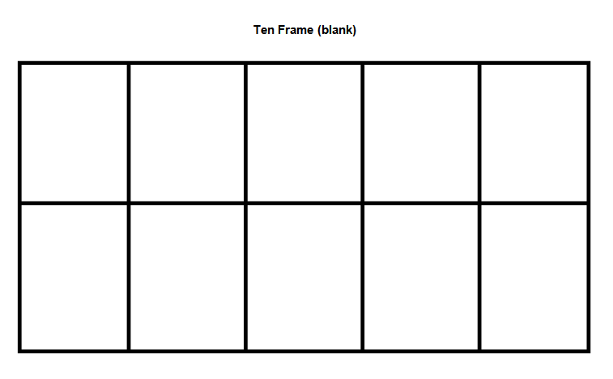

Student 2 - Look for ways to make 10  
I know that 4 and 6 equal 10, so the oatmeal raisin and gingerbread equals 10 cookies. Then, I add the 5 chocolate chip cookies and get 15 total cookies.

Student 3 - Number Line  
I counted on the number line. First, I counted 4, and then I counted 5 more and landed on 9. Then, I counted 6 more and landed on 15. So there were 15 total cookies.

Kansas Association of Teachers of Mathematics (KATM) Flipbooks. Questions or to send feedback: [melisa@ksu.edu](mailto:melisa@ksu.edu). Retrieved from: <http://katm.org/wp/wp-content/uploads/flipbooks/1stFLIPpdf2.pdf>

Be sure to facilitate the student’s thinking with probing questions and drawing out their thinking or composing and decomposing of numbers.

For Example: 9 + 4 + 7 =

Marie thinks that she will decompose the 4 into a 1 and a 3. Why would she decompose the number this way?

9 + 4 + 7 =

1 3

Marie can then make a 10 with

9 + 1 = 10 and

3 + 7 = 10

So 9 + 4 + 7 = 20

In kindergarten, students solve addition and subtraction problems using concrete and pictorial representations. In first grade problems are more complex as students now also begin to represent problems abstractly as equations. Students may use many different representations to solve including drawing a picture, making tally marks, counting on fingers, or representing in their own way.

The unknowns in the problems may also be in any position.

The problem structure is subtle but it is important to see the reasoning involved when solving these types of situations. The Progression Document outlines which problem types grades K-2 are responsible for mastering.



K 1 & 2 2

K 1 & 2 2

K K 1 & 2

1 & 2 2 2

Common Core Standards Writing Team. (2013, September 19). *Progressions for the Common   
 Core State Standards in Mathematics(draft). K-5 Counting and Cardinality and   
 Operations and Algebraic Thinking.* Tucson, AZ: Institute for Mathematics and   
 Educations, University of Arizona.

**Coherence and Connections: Need to Know**

|  |  |  |
| --- | --- | --- |
| Grade Below | Grade-Level | Grade Above |
| K.OA.2 | **1.OA.2** 1.OA.11.MD.4 | 2.OA.1 |

In the Draft of the PARCC Model Content Framework for Mathematics for Grade 1, it stated:

In the previous grade, kindergarten students generally saw equations only when the teacher wrote them on the board; kindergarten students were not expected to write equations themselves. Grade 1 students will write equations for a variety of reasons, such as expressing a decomposition of a number (16 = 9 + 7), expressing a piece of reasoning about numbers (9 + 7 = 9 + 1 + 6 along the way to making ten) or representing a word problem with an unknown (9 + ? = 16). Students use the equal sign appropriately, evaluate the truth of an equation and determine unknown numbers that will make an equation true.

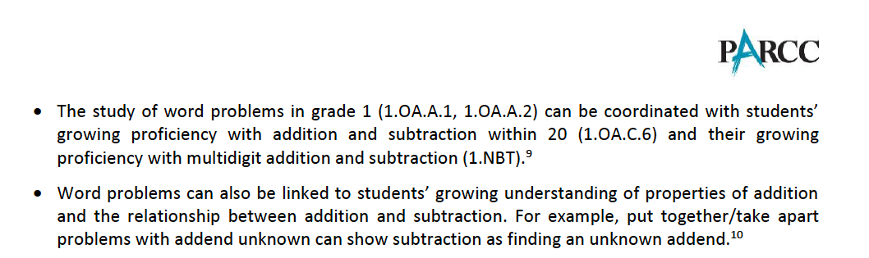

*PARCC Draft Model Content Frameworks: Mathematics Grades K-2* (2013, December).  
 Retrieved May 10, 2014, from <http://parcconline.org/sites/parcc/files/PARCCMCFMathematicsNovember2012V3_FINAL_0.pdf>

There are a variety of methods to change to an easier problem. These draw on addition of three whole numbers, **1.OA.2**. Solve word problems that call for addition of three whole numbers whose sum is less than or equal to 20, e.g., by using objects, drawings, and equations with a symbol for the unknown number to represent the problem. Addition or subtraction can be used to solve a related addition or subtraction by decomposing one addend and composing it with the other addend. For example, a student can change 8+6 to the easier10 + 4 by decomposing 6 =2 + 4 and composing the 2 with the 8 to make 10 = 8 + 6 = 8 + 2 + 4 = 10 + 4 = 14.

Common Core Standards Writing Team. (2013, September 19). *Progressions for the Common   
 Core State Standards in Mathematics(draft). K-5 Counting and Cardinality and   
 Operations and Algebraic Thinking.* Tucson, AZ: Institute for Mathematics and   
 Educations, University of Arizona.

**Classroom Resources**

**PowerPoint Use the graphic organizer to solve problems.**

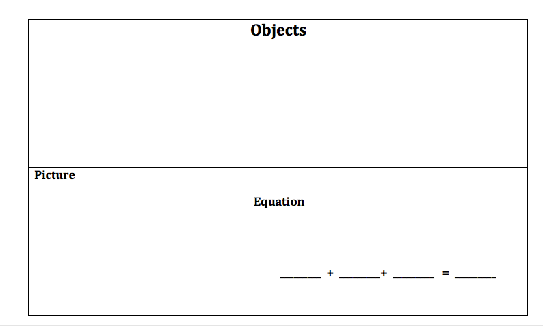

**3 Letter Word Game**

[**http://www.k-5mathteachingresources.com/support-files/threeletteraddends.pdf**](http://www.k-5mathteachingresources.com/support-files/threeletteraddends.pdf)

**HOT Questions**

|  |  |
| --- | --- |
|  |  |
| Using the bug picture to create an addition problems that must be solved by adding three whole numbers | |



You ate 3 different types of fruit and you ate a total of 12 pieces of fruit. What did you eat?

Ann earned 15 super star stickers on Monday, Tuesday, and Wednesday. How many super star stickers did she earn on each day. Solve this problem with two different answers.

Ray and Lauren were playing a dice game. Lauren’s dice roll is below. She said, “I have 13 points because 5 + 3 = 8 and 8 + 5 + 13. Ray said, “I got the total number of points by adding 5 + 5 + 3.” Will Ray also get 13 points like Lauren?

In my bag of candy I have blue, red, and yellow candies. If I want to get the total number of piece, what color should I tart with?

**Additional Resources**

Illustrative Mathematics  
<https://www.illustrativemathematics.org/illustrations/468>

<https://www.illustrativemathematics.org/illustrations/1150>

Howard County 1.OA.2 Wikispace  
<https://grade1commoncoremath.wikispaces.hcpss.org/1.OA.2>

Hawaii Tasks  
<http://standardstoolkit.k12.hi.us/close-to-20-card-game-1-oa-2/>

<http://standardstoolkit.k12.hi.us/cookies-in-cookie-jars-1-oa-2/>

<http://standardstoolkit.k12.hi.us/fruit-salad-1-oa-2/>

<http://standardstoolkit.k12.hi.us/how-many-of-each-1-oa-2/>

<http://standardstoolkit.k12.hi.us/picking-oranges-1-oa-2/>

<http://standardstoolkit.k12.hi.us/three-letter-addends-1-oa-2/>

<http://standardstoolkit.k12.hi.us/who-won-1-oa-2/>

K-5 Teaching Resources  
<http://www.k-5mathteachingresources.com/1st-grade-number-activities.html>

*The Very Hungry Caterpillar* by Eric Carle 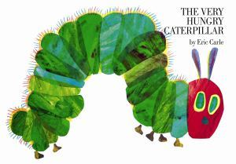

<http://achievethecore.org/page/612/the-very-hungry-caterpillar-task>