Teacher Guide to Clarification

Instructional Math Materials

1.OA.6

Add and subtract within 20.

1.OA.6 Add and subtract within 20, demonstrating fluency for addition and subtraction within 10. Use strategies such as counting on, making ten (e.g., 8 + 6 = 8 + 2 + 4 = 14), decomposing a number leading to a ten (e.g., 13 – 4 = 13 – 3 – 1 = 10 – 1 = 9), using the relationship between addition and subtraction (e.g., knowing that 8 + 4 = 12, one knows 12 – 8 = 4), and creating equivalent 6 + 6 + 1 = 12 + 1 = 13).

MAKING TEN

Make Ten: when one of the addends is a 7, 8, or 9, make it a ten by taking from the other addend. When the numbers are larger, adding with a ten is easier and more efficient then counting on.
Example: 8 + 4 = 12 think: 8 + 4 = 8 + 2 + 2
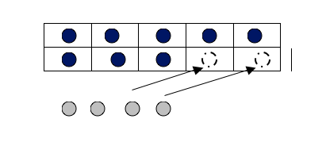
Example: 8 + 7 = ____
Student 1
Making 10 and Decomposing a Number
I know that 8 plus 2 is 10, so I decomposed (broke)
the 7 up into a 2 and 5. First I added 8 and 2 to get
10, and then added the 5 to get 15. 8+7=(8+2)+5=10+5=15
Student 2
Creating an Easier Problem with Known Sums
Known Sums. I know 8 is 7 + 1. I also know that 7 and 7 equal 14 and then I added 1 more to get 15.
8+7=(7+7)+1=15
Example: 14 – 6 = ___
Student 1
Decomposing the Number You Subtract
I know that 14 minus 4 is 10 so I broke the 6 up into a 4 and a 2. 14 minus 4 is 10. Then I take away 2 more to get 8.
14 – 6 = (14 – 14) – 2 = 10 – 2 = 8
Student 2
Relationship between Addition and Subtraction
6 plus __ is 14. I know that 6 plus 8 is 14, so that means that
14 minus 6 is 8.
6+8= 14 so 14 – 6=8
Kansas Association of Teachers of Mathematics (KATM) Flipbooks. Questions or to send feedback: melisa@ksu.edu. Retrieved from: http://katm.org/wp/wp-content/uploads/flipbooks/1stFLIPpdf2.pdf

Coherence and Connections: Need to Know

Students need to see the structure (MP 7) of how 1.OA.6 and MAKING A TEN relate to place value understanding.
If you can’t count on BY 10 FROM ANY number this will not be an efficient strategy.

1.OA.6 is strongly connected to all the standards in this domain. It focuses on students being able to fluently add and subtract numbers to 10

Grade Below | Grade-Level | Grade Above
K.OA.2  K.OA.3  K.OA.4  K.OA.5 | 1.OA.6  1.OA.1  1.OA.3  1.OA.4  1.OA.5  1.NBT.4 | 2.OA.2

Adding fluently refers to knowledge of procedures, knowledge of when and how to use them appropriately, and skill in performing them flexibly, accurately, and efficiently.
- Throughout grades K-4, students should have numerous experiences and develop expertise with breaking numbers apart, DECOMPOSING, and putting them back together in smart ways.
- Efficient strategies (particularly ones based on place value, making ten or getting to the nearest ten) should be used when “mental math” is possible.
- The traditional algorithms for addition and subtraction are expected to be used beginning part of the way through grade 3 and mastered by the end of grade 4.

Standards 1.OA.6 and 1.NBT.5 are such starting places and are essential building blocks for all of the arithmetic of grade 1. They must therefore be given ample attention early in the year. Though often notated on paper, 1.OA.6 and 1.NBT.5 as well as 1.NBT.6 are essentially mental arithmetic knowledge and reasoning.
The study of word problems in grade 1 (1.OA.1, 1.OA.2) can be coordinated with students’ growing proficiency with addition and subtraction within 20 (1.OA.6) and their growing proficiency with multi-digit addition and subtraction (1.NBT).
PARCC Draft Model Content Frameworks: Mathematics Grades K-2 (2013, December).
Retrieved May 10, 2014, from http://parcconline.org/sites/parcc/files/PARCCMCFMathematicsNovember2012V3_FINAL_0.pdf
Classroom Resources

Daily Discourse PowerPoint
Remember the study of word problems can be coordinated with this standard.
True or False 9 + 8 = 9 + 1 + 7

9 + 8 = 9 + 1 + 7

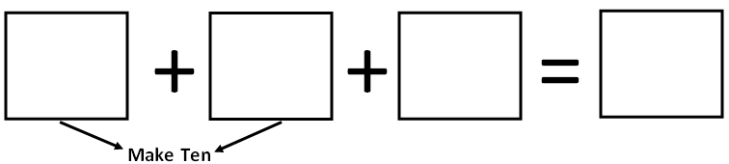

9 + 8 = 10 + 7
9 + 8 = 17

___ + ___

Stephen and James were bowling. Stephen knocked down some pins but she did not knock down all of them. How many more pins did Stephen knock down? Write all possible solutions. Explain your strategy.

Alternatives to timed-tests include
Interviews and observations of
Playing games

HOT Questions

Have students create their own word problems for the two ten frames. Have them solve the problem and show their thinking with words, numbers and pictures.
Have students share their problems with their classmates and sort who solved by using the making a ten strategy.

My Addition Story Problem
Written and Illustrated by ______________________________

Picture | Write a number sentence that matches this story

1.

Additional Resources

Illustrative Mathematics
https://www.illustrativemathematics.org/illustrations/1084
https://www.illustrativemathematics.org/illustrations/1169
Hawaii Tasks
http://standardstoolkit.k12.hi.us/gr-1-subtraction-using-get-to-ten-first-strategy-2/
http://standardstoolkit.k12.hi.us/gr-1-addition-using-make-ten-first-strategy-2/
Inside Mathematics
http://www.insidemathematics.org/index.php/1st-grade
National Library of Virtual Manipulatives
http://nlvm.usu.edu/en/nav/category_g_1_t_1.html

