Teacher Guide to Clarification
4.MD.2

Solve problems involving measurement and conversions of measurements from a larger unit to a smaller unit.
4.MD.2 Use the four operations to solve word problems involving distances, intervals of time, liquid volumes, masses of objects, and money, including problems involving simple fractions or decimals, and problems that require expressing measurements given in a larger unit in terms of a smaller unit. Represent measurement quantities using diagrams such as number line diagrams that feature a measurement scale.
Units and Number Line Diagram

Students will require amply class time to work with different units and their connections to one another. Throughout the year students should develop precision with a variety of units including, but not necessarily limited to, measure, metric, customary, convert/conversion, relative size, liquid volume, mass, length, distance, kilometer (km), meter (m), centimeter (cm), kilogram (kg), gram (g), liter (L), milliliter (mL), inch (in), foot (ft), yard (yd), mile (mi), ounce (oz), pound (lb), cup (c), pint (pt), quart (qt), gallon (gal), time, hour, minute, second, area, perimeter. Students are expected to use these units precisely (MP.6) when labeling a diagram, an answer, in equations, and in explanations of reasoning.
In an effort to help build students’ ability to use appropriate tools strategically (MP.5) allow hands-on experiences with a variety of tools with discussion on how they relate to each other. For example, a ruler (12 inches= 1 foot) and yard stick (1 yard = 3 feet).
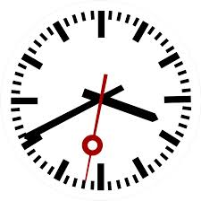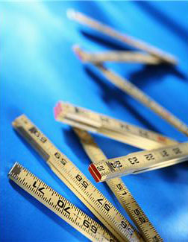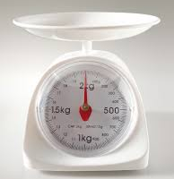
This standard requires students to solve word problems with all four operations.
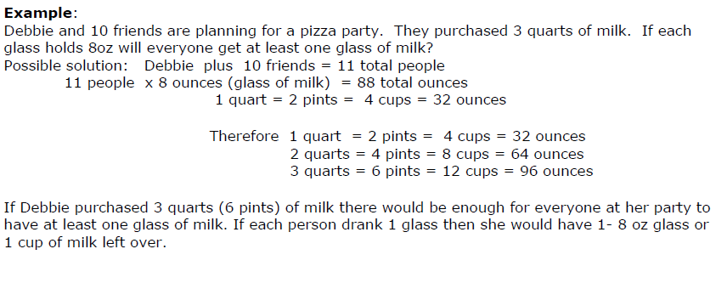
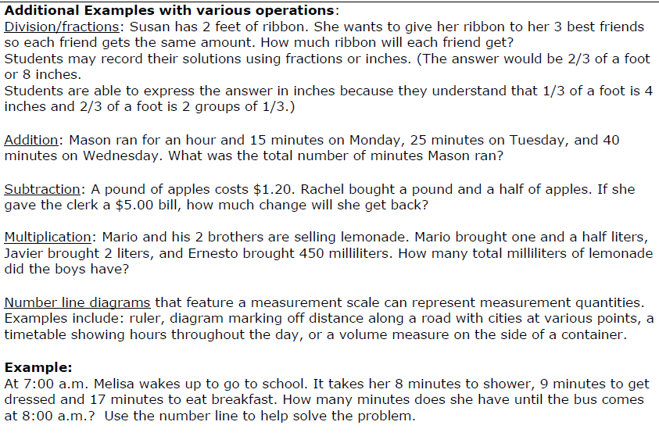
Kansas Association of Teachers of Mathematics (KATM) Flipbooks. Questions or to send feedback: melisa@ksu.edu. Retrieved from: http://katm.org/wp/wp-content/uploads/flipbooks/4FlipBookedited.pdf
Remember to only use problems with denominators that are 2, 3, 4, 5 6, 8, 10, 12 and 100

Coherence and Connections: Need to Know

The work that students do with units of measure (4.MD.1-2) and with multiplication of a fraction by a whole number (4.NF.4) can be connected to the idea of “times as much” in multiplication (4.OA.1)
Standard 4.MD.2 refers to using the four operations to solve word problems involving measurement quantities such as liquid volume, mass, time, and so on. Some parts of this standard could be met earlier in the year (such as using whole-number multiplication to express measurements given in a larger unit in terms of a smaller unit — see also 4.MD.1), while others might be met only by the end of the year (such as word problems involving addition and subtraction of fractions or multiplication of a fraction by a whole number — see also 4.NF.3d and 4.NF.4c).
PARCC Model Content Frameworks: Mathematics Grades 3-11 (version 3). (2012, November
1). Retrieved June 3, 2014, from http://parcconline.org/sites/parcc/files/PARCCMCFMathematicsNovember2012V3_FINAL_0.pdf
Evidence  Statement Key | Evidence Statement Text | Clarifications | MP
4.MD.2-1  EOY | Use the four operations to solve word problems involving distances, intervals of time, liquid volumes, masses of objects, and money, in problems that require expressing measurements given in a larger unit in terms of a smaller unit. Represent measurement quantities using diagrams such as number line diagrams that feature a measurement scale. | i) Situations involve whole-number measurements and require expressing measurements given in a larger unit in terms of a smaller unit.  ii) Tasks may present number line diagrams featuring a measurement scale.  iii) Tasks may include measuring to the nearest cm or mm. | 4,5
4.MD.2-2  EOY | Use the four operations to solve word problems involving distances, intervals of time, liquid volumes, masses of objects, and money, in problems involving simple fractions or decimals. Represent measurement quantities using diagrams such as number line diagrams that feature a measurement scale. | i) Situations involve two measurements given in the same units, one a whole-number measurements and the other a non-whole number measurement (given as a fraction or a decimal).  ii) Tasks may present number line diagrams featuring a measurement scale.  iii) Tasks may include measuring to the nearest cm or mm. | 4,5
PARCC Mathematics Evidence Tables. (2013, April). Retrieved from:
http://www.parcconline.org/assessment-blueprints-test-specs

2.MD.8: Solve word problems involving dollar bills, quarters, dimes, nickels, and pennies, using $ and ¢ symbols appropriately. Example: If you have 2 dimes and 3 pennies, how many cents do you have?

3.MD.1: Tell and write time to the nearest minute and measure time intervals in minutes. Solve word problems involving addition and subtraction of time intervals in minutes, e.g., by representing the problem on a number line diagram.

3.MD.2: Measure and estimate liquid volumes and masses of objects using standard units of grams (g), kilograms (kg), and liters (l).6 Add, subtract, multiply, or divide to solve one-step word problems involving masses or volumes that are given in the same units, e.g., by using drawings (such as a beaker with a measurement scale) to represent the problem.

4.NF.5: Express a fraction with denominator 10 as an equivalent fraction with denominator 100, and use this technique to add two fractions with respective denominators 10 and 100. For example, express 3/10 as 30/100, and add 3/10 + 4/100 = 34/100.

4.NF.6: Use decimal notation for fractions with denominators 10 or 100. For example, rewrite 0.62 as 62/100; describe a length as 0.62 meters; locate 0.62 on a number line diagram.
Grade Below | Grade-Level | Grade Above
 | 4.OA.3  4.NF.3a-d  4.NF.4c  4.NF.5  4.NF.6  4.MD.1  4.MD.2 | 5.NF.3  5.NF.5  5.NF.6  5.MD.1

Classroom Resources

Powerpoint
Time Line Diagram: http://www.k-5mathteachingresources.com/support-files/elapsedtimerulersample1.pdf
Time Line Diagram 2: http://www.k-5mathteachingresources.com/support-files/elapsedtimerulersample2.pdf
24 Hour Line Diagram: http://www.k-5mathteachingresources.com/support-files/24hournumberline.pdf

HOT Questions

- There are three buckets carrying water. Bucket 1 has 9 ¼ gallons. Bucket 2 has 41.5 quarts. Bucket 3 has 140 cups. How much water is there in total?
- Write a story problem where the answer is 4 3/8 feet.
- At the fair, the puppet show started at 8:38am and ended at 10:45am. Storytime was ¾ hour longer than the puppet show. How long was storytime? Taken from https://grade4commoncoremath.wikispaces.hcpss.org/4.MD.2
- Use a number line diagram to solve the following problem. Janice read for 1 hour and 15 minutes on Monday, 25 minutes on Tuesday, 1 hour and 12 minutes on Wednesday and 50 minutes on Thursday. If Janice wants to read for 5 hours total by the end of the week, how much longer does Janice need to read?
For more HOT Questions go to: http://www.k-5mathteachingresources.com/support-files/4thgrademeasproblems.pdf
Additional Resources

https://www.illustrativemathematics.org/illustrations/873
http://www.insidemathematics.org/assets/problems-of-the-month/courtney's%20collection.pdf
http://www.insidemathematics.org/assets/problems-of-the-month/diminishing%20return.pdf
http://www.insidemathematics.org/assets/problems-of-the-month/movin%20'n%20groovin.pdf
http://www.insidemathematics.org/assets/problems-of-the-month/once%20upon%20a%20time.pdf
http://www.insidemathematics.org/assets/problems-of-the-month/piece%20it%20together.pdf

