Teacher Guide to Clarification
4.NBT.6

Use place value understanding and properties of operations to perform multi-digit arithmetic.
4.NBT.6 Find whole-number quotients and remainders with up to four-digit dividends and one-digit divisors, using strategies based on place value, the properties of operations, and/or the relationship between multiplication and division, illustrate and explain the calculation by using equations, rectangular arrays, and/or area models.
Place Value Strategies & Properties of Operations

Students should be encouraged to use any of the strategies they already know to solve division problems. Teachers need to encourage them to write equations alongside their drawings or models.
Ample time should be spent discussing the relationship between multiplication and division.
Examples:
A 4th grade teacher bought 4 new pencil boxes. She has 260 pencils. She wants to put the pencils in the boxes so that each box has the same number of pencils. How many pencils will there be in each box?
- Using Base 10 Blocks: Students build 260 with base 10 blocks and distribute them into 4 equal groups. Some students may need to trade the 2 hundreds for tens but others may easily recognize that 200 divided by 4 is 50.
- Using Place Value: 260 ÷ 4 = (200 ÷ 4) + (60 ÷ 4)
- Using Multiplication: 4 x 50 = 200, 4 x 10 = 40, 4 x 5 = 20; 50 + 10 + 5 = 65; so 260 ÷ 4 = 65

This standard calls for students to explore division through various strategies.

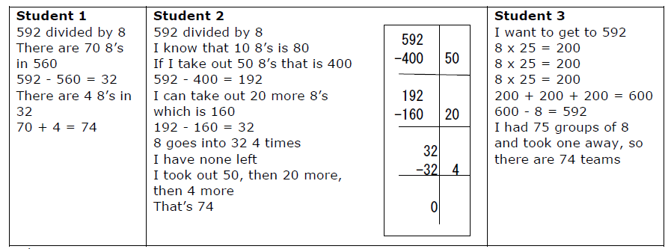

Example 1:
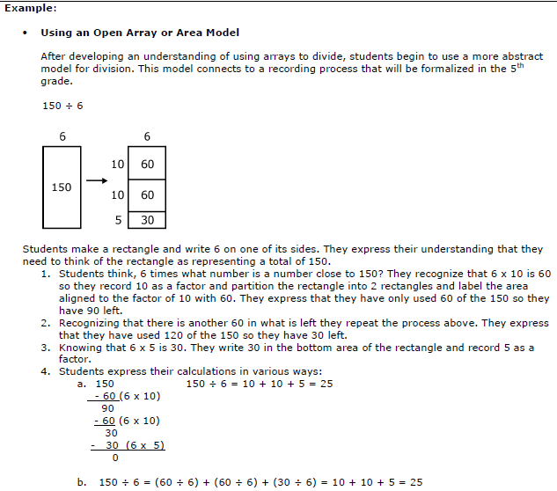
See how these examples address the relationship between multiplication and division.
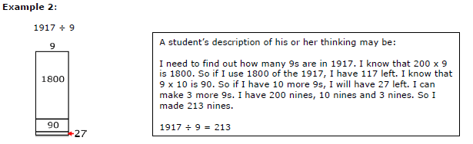

Kansas Association of Teachers of Mathematics (KATM) Flipbooks. Questions or to send feedback: melisa@ksu.edu. Retrieved from: http://katm.org/wp/wp-content/uploads/flipbooks/4FlipBookedited.pdf

General methods for computing quotients of multi-digit numbers and one-digit numbers rely on the same understandings as for multiplication, but cast in terms of division (4.NBT.6). One component is quotients of multiples of 10, 100, or 1000 and one-digit numbers. For example, 42 ÷ 6 is related to 420 ÷ 6 and 4200 ÷ 6. Students can draw on their work with multiplication and they can also reason that 4200 ÷ 6 means partitioning 42 hundreds into 6 equal groups, so there are 7 hundreds in each group.
Another component of understanding general methods for multi-digit division computation is the idea of decomposing the dividend into like base-ten units and finding the quotient unit by unit, starting with the largest unit and continuing on to smaller units. As with multiplication, this relies on the distributive property. This can be viewed as finding the side length of a rectangle (the divisor is the length of the other side) or as allocating objects (the divisor is the number of groups).
Solving division problems with division arrays allows students to see the relationship between multiplication and division.
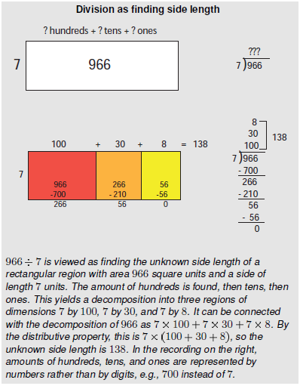
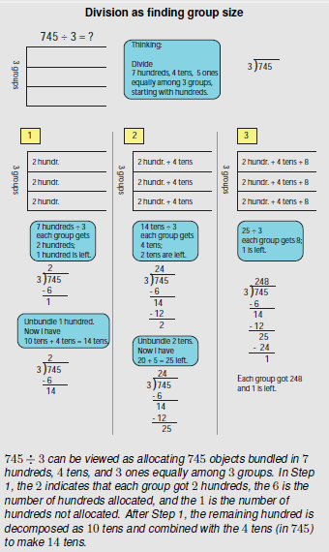
Multi-digit division requires working with remainders. In preparation for working with remainders, students compute sums of a product and a number, such as 4 x 8 + 3. In multi-digit division, students will need to find the greatest multiple less than a givn number. For example, when dividing by 6, the greatest multiple of 6 less than 50 is 6 x 8 = 48. Students can think of these “greatest multiples” in terms of putting objects into groups. For example, when 50 objects are shared among 6 groups, the largest whole number of objects that can be put in each group is 8, and 2 objects are left over. (Or when 50 objects are allocated into groups of 6, the largest whole number of groups that can be made is 8, and 2 objects are left over.) The equation 6 x 8 + 2= 50 (or 8 x 6 + 2= 50) corresponds with this situation.
Cases involving 0 in division may require special attention.
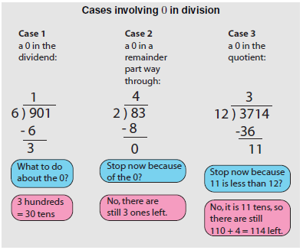
Common Core Standards Writing Team. (2013, September 19). Progressions for the Common
Core State Standards in Mathematics(draft). K-5 Number and Operations in Base 10.
Tucson, AZ: Institute for Mathematics and Educations, University of Arizona.
Write problems in a variety of ways: 782 ÷ 3, $\frac{782}{3}$, 3 782

Coherence and Connections: Need to Know

Students combine their understanding of the meanings and properties of multiplication and division with their understanding of base-ten units to begin to multiply and divide multi-digit numbers (4.NBT.5-6; this builds on work done in grade 3, cf. 3.NBT.3)
4.NBT.6 | When students work toward meeting this standard, they combine prior understanding  of multiplication and division with deepening understanding of the base-ten system of  units to find whole-number quotients and remainders with up to four-digit dividends  and one-digit divisors. This work will develop further in grade 5 and culminate in  fluency with the standard algorithms in grade 6.

PARCC Model Content Frameworks: Mathematics Grades 3-11 (version 3). (2012, November
1). Retrieved June 3, 2014, from http://parcconline.org/sites/parcc/files/PARCCMCFMathematicsNovember2012V3_FINAL_0.pdf
Evidence  Statement Key | Evidence Statement Text | Clarifications | MP
4.NBT.6-1  PBA & EOY | Find whole-number quotients and remainders with up to three-digit dividends and one-digit divisors, using strategies  based on place value, the properties of operations, and/or the relationship between multiplication and division. | i) Tasks do not have a context.  ii) The illustrate/explain aspect of 4.NBT.6 is not assessed here. | 7,8
4.NBT.Int.1  PBA & EOY | Perform computations by applying conceptual understanding of place value, rather than by applying multi-digit algorithms. | i) Tasks do not have a context.  ii) See ITN Appendix F, section A, “Illustrations of Innovative Task Characteristics,” subsection 4, “Integrative tasks with machine scoring of responses entered by computer interface.” | 1,7
4.C.1-2  PBA | Base explanations/ reasoning on the properties of operations.  Content Scope: Knowledge and skills articulated in 4.NBT.6 | i) Students need not use technical terms such as commutative, associative, distributive, or property.  ii) Tasks do not have a context. | 3,6,7,  8
4.C.2  PBA | Base explanations/ reasoning on the relationship between addition and subtraction or the relationship between multiplication and division. Content Scope: Knowledge and skills articulated in 4.NBT.6 | i) Tasks do not have a context. | 3,6,7
4.NBT.6-2  EOY | Find whole-number quotients and remainders with four-digit dividends and one-digit divisors, using strategies based on  place value, the properties of operations, and/or the relationship between multiplication and division. | i) Tasks do not have a context.  ii) The illustrative/explain aspect of 4.NBT.6 is not assessed here. | 7,8
4.Int.5  EOY | Solve multi-step word problems posed with whole numbers and involving computations best performed by applying conceptual understanding of place value, perhaps involving rounding. See 4.OA.3, 4.NBT | None | 1,2,7
PARCC Mathematics Evidence Tables. (2013, April). Retrieved from:
http://www.parcconline.org/assessment-blueprints-test-specs
Grade Below | Grade-Level | Grade Above
3.OA.5  3.OA.7  3.NBT.2 | 4.OA.3  4.NBT.1  4.NBT.5  4.NBT.6 | 5.NBT.6

Classroom Resources

Powerpoint
Suggestions on a Teacher’s Blog: http://shutthedoorandteach.blogspot.com/2012/03/success-with-my-long-division-mini-unit.html
Teacher guide on virtual manipulatives: https://grade4commoncoremath.wikispaces.hcpss.org/file/view/Directions%20for%20Virtual%20Manipulatives%204.NBT.6.pdf/516500896/Directions%20for%20Virtual%20Manipulatives%204.NBT.6.pdf
Teacher Video: https://www.teachingchannel.org/videos/common-core-teaching-division

HOT Questions

- Solve $\frac{3916}{7}$. Use a drawing or model to illustrate the problem. Write an equation. Explain the relationship between multiplication and division in this problem.
- Write and equation based on the rectangular array below. Then solve it and explain your reasoning.
100 + 40 + 9
6
Additional Resources

Illustrative Mathematics
https://www.illustrativemathematics.org/illustrations/1774
NCTM Illuminations
http://illuminations.nctm.org/Activity.aspx?id=4197
Howard County 4.NBT.6 Wikispace
https://grade4commoncoremath.wikispaces.hcpss.org/file/view/4NBT5.6.The%20BakerProblemSolvingTask.pdf/440849346/4NBT5.6.The%20BakerProblemSolvingTask.pdf
https://grade4commoncoremath.wikispaces.hcpss.org/file/view/4.NBT.6_Whatis2500dividedby300.pdf/457299682/4.NBT.6_Whatis2500dividedby300.pdf
https://grade4commoncoremath.wikispaces.hcpss.org/file/view/4.NBT.6_4.OA.3_CompatibleNumberstoEstimate.pdf/457299670/4.NBT.6_4.OA.3_CompatibleNumberstoEstimate.pdf
Math Solutions
http://www.mathsolutions.com/documents/0-941355-42-X_L3.pdf
K-5 Math Teaching Resources
http://www.k-5mathteachingresources.com/support-files/division-strategy-partial-quotients1.pdf
http://www.k-5mathteachingresources.com/support-files/division-strategy-partial-quotients2.pdf
http://www.k-5mathteachingresources.com/support-files/division-strategy-partition-the-dividend.pdf
New South Wales Department of Education
http://www.curriculumsupport.education.nsw.gov.au/countmein/children_remainders_count.html
Vector Kids
http://www.vectorkids.com/vkdivisible.htm

