Teacher Guide to Clarification
4.NF.2

Extend understanding of fraction equivalence and ordering.
4.NF.2 Compare two fractions with different numerators and different denominators, e.g., by creating common denominators or numerators, or by comparing to a benchmark fraction such as ½. Recognize that comparisons are valid only when the two fractions refer to the same whole. Record the results of comparisons with symbols >, =, or <, and justify the conclusions, e.g., by using a visual fraction model.
Common Numerator, Benchmark Fraction, Models

In fourth grade students should be given plenty of opportunity to use models to compare fractions. They should not be expected or pushed to use any kind of standard algorithm. It is also important to discuss the meaning of comparisons and to explain why fractions need to be referring to the same whole. There is difference between someone getting ½ the fries from a small fry and ½ the fries from a large fry. Encourage student discussion around this idea.

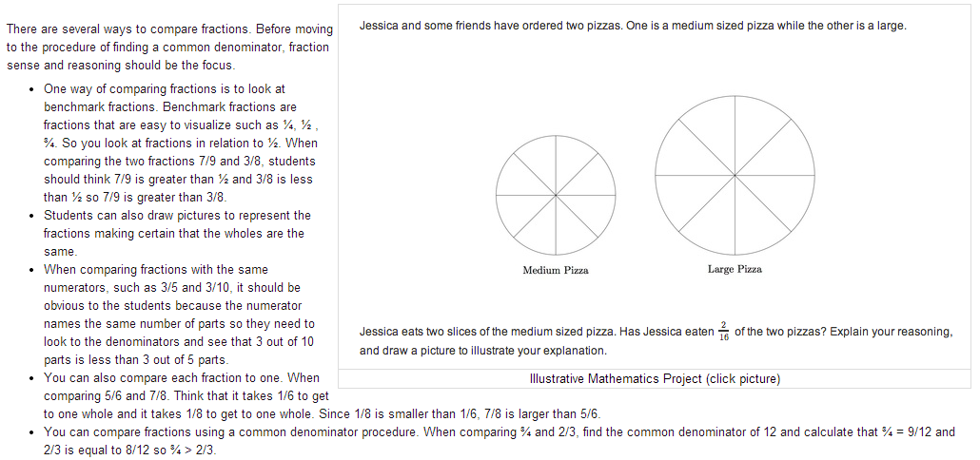
https://grade4commoncoremath.wikispaces.hcpss.org/4.NF.2

Below are some examples of comparing fractions using a variety of models:

Example:
Both Melisa and Nancy shaded 1/3 of their grids, but they are not comparing the same whole. Discuss the consequence of this concept with the class.

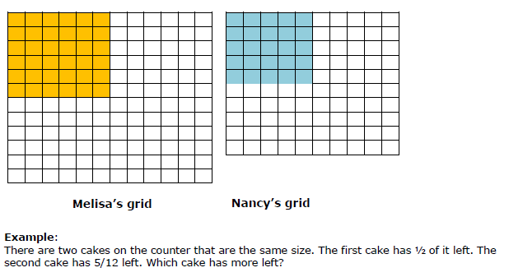
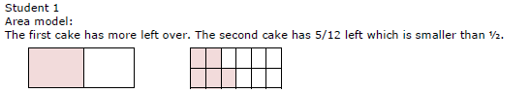
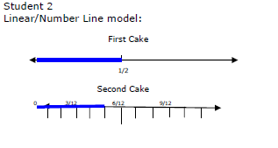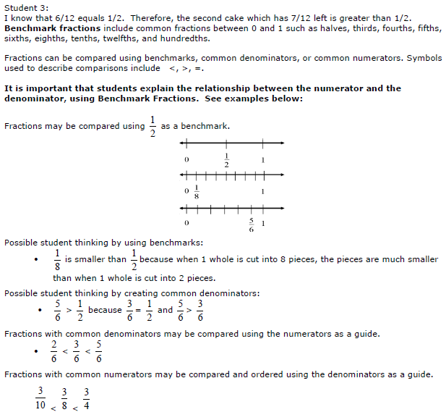

Kansas Association of Teachers of Mathematics (KATM) Flipbooks. Questions or to send feedback: melisa@ksu.edu. Retrieved from: http://katm.org/wp/wp-content/uploads/flipbooks/4FlipBookedited.pdf

Grade 4 students use their understanding of equivalent fractions to compare fractions with different numerators and different denominators (4.NF.2). For example, to compare $\frac{5}{8}$ and $\frac{7}{12}$ they rewrite both fractions as $\frac{60}{96}\left(=\frac{12 x 5}{12 x 8}\right)$ and
$\frac{56}{96}\left(=\frac{7 x 8}{12 x 8}\right)$. Because $\frac{60}{96}$ and $\frac{56}{96}$ have the same denominator, students can compare using Grade 3 methods and see that $\frac{56}{96}$ is smaller, so $\frac{7}{12}$ < $\frac{5}{8}$.
Students also reason using benchmarks such as ½ and 1. For example, they see that $\frac{7}{8}$ < $\frac{13}{12}$ because $\frac{7}{8}$ is less than 1 (and is therefore to the left of 1) but $\frac{13}{12}$ is greater than 1 (and is therefore to the right of 1).
Grade 5 students who have learned about fraction multiplication can see equivalence as “multiplying by 1”. $\frac{7}{9}=\frac{7}{9}x1=\frac{7}{9}x\frac{4}{4}=\frac{28}{36}$
However, although a useful mnemonic device, this does not constitute a valid argument at this grade, since students have not yet learned fraction multiplication.
Common Core Standards Writing Team. (2013, September 19). Progressions for the Common
Core State Standards in Mathematics(draft). K-5 Number and Operations in Base 10.
Tucson, AZ: Institute for Mathematics and Educations, University of Arizona.
Coherence and Connections: Need to Know

PARCC Evidence Tables:
Evidence  Statement Key | Evidence Statement Text | Clarifications | MP
4.NF.2-1  PBA & EOY | Compare two fractions with different numerators and different denominators, e.g., by creating common denominators or by comparing to a benchmark fraction such as 1/2. Record the results of comparisons with symbols <, =, or >. | i) The justification aspect of 4.NF.2 is not assessed here.  ii) The aspect of recognizing that fraction comparisons are valid  only when the two fractions refer to the same whole, is not assessed here.  iii) Tasks require the student to choose the comparison strategy autonomously depending on the given fraction.  iv) Tasks are limited to denominators 2, 3, 4, 5, 6, 8, 10, 12, and 100 (CCSS footnote, p. 30).  v) Tasks may include fractions that equal whole numbers. | 6,7
4.NF.A.Int.1  PBA & EOY | Apply conceptual understanding of fraction equivalence and ordering to solve simple word problems requiring fraction comparison. | i) Tasks have “thin context.”  ii) Tasks do not require adding, subtracting, multiplying, or dividing fractions.  iii) Prompts do not provide visual fraction models; students may at their discretion draw visual fraction models as a strategy.  iv) Tasks are limited to denominators 2, 3, 4, 5, 6, 8, 10, 12, and 100 (CCSS footnote, p. 30) | 1,4,5
4.C.4-1  PBA | Base arithmetic explanations/reasoning on concrete referents such as diagrams (whether provided in the prompt or constructed by the student in her response), connecting the diagrams to a written (symbolic) method.  Content Scope: Knowledge and skills articulated in 4.NF.A | i) Tasks have “thin context” or no context.  ii) Tasks are limited to denominators 2, 3, 4, 5, 6, 8, 10, 12, and 100 (CCSS footnote, p. 30). | 3,5,6
4.C.5-2  PBA | Distinguish correct explanation/reasoning from that which is flawed, and – if there is a flaw in the argument – present corrected reasoning. (For example, some flawed “student” reasoning is presented and the task is to correct and improve it.) Content Scope: Knowledge and skills articulated in 4.NF.1 | i) Tasks have “thin context” or no context.  ii) Tasks are limited to denominators 2, 3, 4, 5, 6, 8, 10, 12, and 100 (CCSS footnote, p. 30) | 3,7,6
4.C.5-3  PBA | Distinguish correct explanation/reasoning from that which is flawed, and – if there is a flaw in the argument – present corrected reasoning. (For example, some flawed “student” reasoning is presented and the task is to correct and improve it.) Content Scope: Knowledge and skills articulated in 4.NF.2 | i) Tasks have “thin context” or no context.  ii) Tasks are limited to denominators 2, 3, 4, 5, 6, 8, 10, 12, and 100 (CCSS footnote, p. 30). | 3,7,6
4.C.7-2  PBA | Base explanations/ reasoning on a number line diagram (whether provided in the prompt or constructed by the student in her response).  Content Scope: Knowledge and skills articulated in 4.NF.2 | None | 3,5,6
4.NF.Int.1  EOY | Solve one-step word problems requiring integration of knowledge and skills articulated in 4.NF. | i) See ITN Appendix F, section A, “Illustrations of Innovative  Task Characteristics,” subsection 4, “Integrative tasks with machine scoring of responses entered by computer interface.”  ii) Tasks are limited to denominators 2, 3, 4, 5, 6, 8, 10, 12, and 100 (CCSS footnote, p. 30). | 1,4
4.NF.Int.2  EOY | Express a fraction with denominator 10 as an equivalent fraction with denominator 100, and use this technique to add two fractions with respective denominators 10 and 100. For example, express 3/10 as 30/100, and add$\frac{3}{10}+\frac{4}{100}=\frac{34}{100}$ | i) Tasks are one-step addition word problems of one of two kinds: Add To with result unknown, or Put Together with result unknown.  ii) See Table 2, p. 9 of the Progression for Operations and  Algebraic Thinking; these situations are sampled equally. | 1
PARCC Mathematics Evidence Tables. (2013, April). Retrieved from:
http://www.parcconline.org/assessment-blueprints-test-specs

Grade Below | Current Grade | Grade Above
3.OA.3  3.NF.3 | 4.NF.1  4.NF.2  4.NF.7 | 5.NF.2

Classroom Resources

Powerpoint
Quick Video for teachers from Illustrative Mathematics https://www.illustrativemathematics.org/fractions_progression
Teacher Guide for Glencoe’s Virtual Manipulatives: https://grade4commoncoremath.wikispaces.hcpss.org/file/view/Directions%20for%20Virtual%20Manipulatives%204.NF.2.pdf/516500914/Directions%20for%20Virtual%20Manipulatives%204.NF.2.pdf
A variety of virtual manipulatives from the National Library of Virtual Manipulatives: http://nlvm.usu.edu/en/nav/grade_g_2.html

HOT Questions

- Amanda has 2/8 of a bag of candy filled. Sula has 1/3 of the same size bag of candy filled. If Amanda and Sula combine their bags are they equivalent, less than or more than ½? ¾? 1? Explain your reasoning.
- How does the value of a fraction change if you double its numerator? Explain your answer. How does the value of a fraction change if you double its denominator? Explain your answer. https://www.illustrativemathematics.org/illustrations/183
- List the following fractions in order from greatest to least: 2/3, 3/5, 7/8, ½, 4/7. Use visual fraction models to support your answer.

Additional Resources

https://www.illustrativemathematics.org/illustrations/812
https://www.illustrativemathematics.org/illustrations/811
https://learnzillion.com/lessonsets/7-compare-fractions-of-different-types
Fraction Card Game: https://grade4commoncoremath.wikispaces.hcpss.org/file/view/4.NF.2_FractionCardGames.pdf/457305362/4.NF.2_FractionCardGames.pdf
http://www.k-5mathteachingresources.com/support-files/birthday-fractions-4nf2.pdf
http://www.k-5mathteachingresources.com/support-files/pattern-block-fractions-4nf2.pdf
http://illuminations.nctm.org/Lesson.aspx?id=1728
http://www.pbslearningmedia.org/resource/vtl07.math.number.nums.lpnumbline/locating-and-ordering-equivalent-fractions-on-the-number-line/
https://grade4commoncoremath.wikispaces.hcpss.org/file/view/More%20or%20Less.pdf/402794796/More%20or%20Less.pdf
https://grade4commoncoremath.wikispaces.hcpss.org/file/view/4.NF.1_4.NF.2_FractionBuckets.pdf/457305264/4.NF.1_4.NF.2_FractionBuckets.pdf

