Teacher Guide to Clarification
4.OA.2

Use the four operations with whole numbers to solve problems.
4.OA.2 Multiply or divide to solve word problems involving multiplicative comparison, e.g., by using drawings and equations with a symbol for the unknown number to represent the problem, distinguishing multiplicative comparison from additive comparison.
Multiplicative Comparison

When distinguishing multiplicative comparison from additive comparison, students should note that:
• additive comparisons focus on the difference between two quantities (e.g., Deb has 3 apples and Karen has 5 apples. How many more apples does Karen have?). A simple way to remember this is, “How many more?”
• multiplicative comparisons focus on comparing two quantities by showing that one quantity is a specified number of times larger or smaller than the other (e.g., Deb ran 3 miles. Karen ran 5 times as many miles as Deb. How many miles did Karen run?). A simple way to remember this is “How many times as much?” or “How many times as many?”
This standard calls for students to translate comparative situations into equations with an unknown and solve. Students need many opportunities to solve contextual problems.
Examples:
Unknown Product: A blue scarf costs $3. A red scarf costs 6 times as much. How much does the red scarf cost? (3 x 6 = p).
Group Size Unknown: A book costs $18. That is 3 times more than a DVD. How much does a DVD cost? (18 ÷ p = 3 or 3 x p = 18).
Number of Groups Unknown: A red scarf costs $18. A blue scarf costs $6. How many times as much does the red scarf cost compared to the blue scarf? (18 ÷ 6 = p or 6 x p = 18).
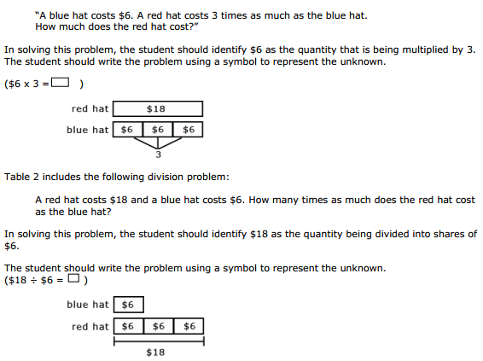
Kansas Association of Teachers of Mathematics (KATM) Flipbooks. Questions or to send feedback: melisa@ksu.edu. Retrieved from: http://katm.org/wp/wp-content/uploads/flipbooks/4FlipBookedited.pdf
Coherence and Connections: Need to Know

Consider two diving boards, one 40 feet high, the other 8 feet high. Students in earlier grades learned to compare these heights in an additive sense – “This one is 32 feet higher than that one” – by solving additive Compare problems (2.OA.1) and using addition and subtraction to solve word problems involving length (2.MD.5). Students in Grade 4 learn to compare these quantities multiplicatively as well: “This one is 5 times as high as that one” (4.OA.1, 4.OA.2, 4.MD.1, 4.MD.2). In an additive comparison, the underlying question is what amount would be added to one quantity in order to result in the other. In a multiplicative comparison, the underlying question is what factor would multiply one quantity in order to result in the other.
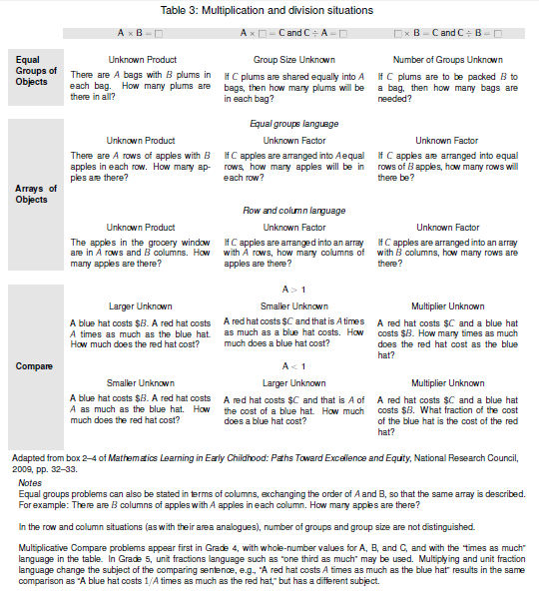
Language can be difficult in Multiplication Compare problems. The language used in the three examples in table 3 is fairly simple, e.g., “A red hat costs 3 times as much as the blue hat.” Saying the comparing sentence in the opposite way is more difficult. It could be said using division, e.g., “The cost of a red hat divided by 3 is the cost of the blue hat.” It could also be said using a unit fraction, e.g., “A blue hat costs one-third as much as a red hat”; note however that multiplying a fraction is not an expectation of the Standards in Grade 4. In any case, many languages do not use either of these options for saying the opposite comparison. They use the terms three times more than and three times less than to describe the opposite multiplicative comparisons. These did not use to be acceptable usages in English because they mix the multiplicative and additive comparisons and as ambiguous. If the cost of a red hat is three times more than a blue hat that costs $5, does a red hat cost $15 (three times as much) or $20 (three times more than: a difference that is 3 times as much)? However, the terms three times more than and three times less than are now appearing frequently in newspapers and other written materials. It is recommended to discuss these complexities with Grade 4 students while confining problems that appear on tests or in multi-step problems to the well-defined multiplication language.
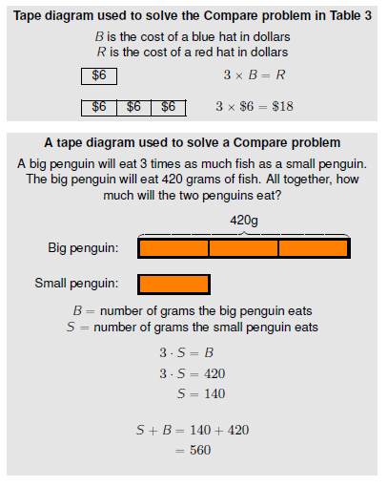

Common Core Standards Writing Team. (2013, September 19). Progressions for the Common
Core State Standards in Mathematics(draft). K-5 Counting and Cardinality and
Operations and Algebraic Thinking. Tucson, AZ: Institute for Mathematics and
Educations, University of Arizona.

Evidence  Statement Key | Evidence Statement Text | Clarifications | MP
4.OA.2  PBA & EOY | Multiply or divide to solve word problems involving multiplicative comparison, e.g., by using drawings and equations with a symbol for the unknown number to  represent the problem, distinguishing multiplicative comparison from additive comparison. | i) See the Progression for Operations and Algebraic Thinking, especially page 29 and Table 3 on page 23.  ii) Tasks sample equally the situations in the third row of Table 2, p. 89, in CCSS. | 1,4,5
PARCC Mathematics Evidence Tables. (2013, April). Retrieved from:
http://www.parcconline.org/assessment-blueprints-test-specs

Grade Below | Grade-Level | Grade Above
3.OA.2 | 4.OA.1  4.OA.2  4.NF.4a  4.MD.1 | 5.OA.2  5.NF.3  5.NF.5  5.NF.6

Classroom Resources

Powerpoint

HOT Questions

- If Alanna has 6 times as many stickers as Sarah and together they have 63 stickers, how many stickers do Alanna and Sarah each have?
- Mason made 5 baskets while playing basketball during P.E. Ayden made 3 times as many. How many baskets did Ayden make? How many points did Mason and Ayden each get? Explain your answer using an equation and a drawing. (Students will likely get different points since each basket could be worth 1,2 or 3 depending on what type of shot it was.)
- A Great Dane is 24 times the size of a Chihuahua, on average. A Great Dane is 120 pounds. How much would the Great Dane and the Chihuahua weigh together?
- One year a strawberry plant was 2 inches tall and an Oak tree was 720 inches tall. The next year the strawberry plant was 4 inches tall and the Oak tree was 727 inches tall. Which grew more? Explain your reasoning. (related to https://www.illustrativemathematics.org/illustrations/356)

Additional Resources

https://www.illustrativemathematics.org/illustrations/263
https://www.illustrativemathematics.org/illustrations/356
https://www.illustrativemathematics.org/illustrations/357
https://learnzillion.com/lessonsets/615-solve-word-problems-using-multiplicative-comparisons
http://www.engageny.org/ccls/4oa2
http://www.insidemathematics.org/common-core-math-tasks/4th-grade/4-2006%20Bikes%20and%20Trikes.pdf

