Teacher Guide to Clarification

Instructional Math Materials

5.MD.5b

Geometric measurement: understand concepts of volume and relate volume to multiplication and to addition.

5.MD.5b Relate volume to the operations of multiplication and addition and solve real world and mathematical problems involving volume.
- Apply the formulas V = l × w × h and V = b × h for rectangular prisms to find volumes of right rectangular prisms with whole number edge lengths in the context of solving real world and mathematical problems.
V = l × w × h and V = b × h

Explanation: Students need multiple opportunities to measure volume by filling rectangular prisms with cubes and looking at the relationship between the total volume and the area of the base. They derive the volume formula (volume equals the area of the base times the height) and explore how this idea would apply to other prisms. Students use the associative property of multiplication and decomposition of numbers using factors to investigate rectangular prisms with a given number of cubic units.
Example
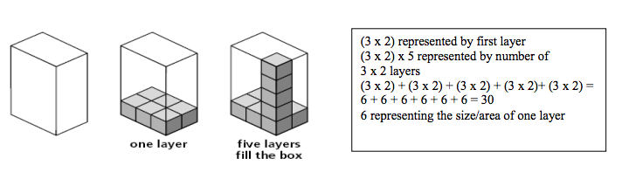

The PARCC assessment will have multiple-choice questions with more then one right answer. Students need to practice this format before they actually take the assessment
Example
If this box is packed with unit cubes without gaps or overlaps, which three expressions can be used to find the volume of the box?
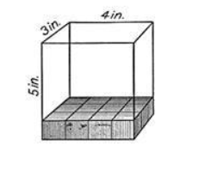
a. 5 x 3 x 4
b. 12 x 5
c. 5 + 3 + 4
d. 12 + 12 + 12 + 12
e. 15 + 15 + 15 + 15

Coherence and Connections: Need to Know

Grade Below | Grade-Level | Grade Above
None | 5.MD.5b  5.MD.5a  5.MD.5c | 6.G.1  6.G.2

Evidence  Statement Key | Evidence Statement Text | Clarifications | MP
5.C.1.3 | Base explanations/reasoning on the properties of operations. Content Scope: Knowledge and skills articulated in 5.MD.5a | None | 2, 3, 7, 6
5.C.6 | Base explanations/reasoning on concrete referents such as diagrams (whether provided in the prompt or constructed by the student in her response.) Content Scope: Knowledge and skills articulated in 5.MD.C | None | 3, 5, 6
5.C.8.2 | Present solutions to multi-step problems in the form of valid chains of reasoning, using symbols such as equal signs appropriately (for example, rubrics award less than full credit for the presence of nonsense statements such as  1+ 4 = 5+ 7 = 12, even if the final answer is correct), or identify or describe errors in solutions to multi-step problems and present corrected solutions. Content Scope: Knowledge and skills articulated in 5.MD.5c | None | 3, 5, 6
5.MD.5b | Relate volume to the operations of multiplication and addition and solve real world and mathematical problems involving volume.  b. Apply the formulas  V = l × w × h and V = B × h for rectangular prisms to find volumes of right rectangular prisms with whole-number edge lengths in the context of solving real world and mathematical problems. | - Pool should contain tasks with and without contexts.  - 50% of tasks involve use of  V = l × w × h, 50% of tasks involve use of V=B × h.  iii) Tasks may require students to measure to find edge lengths to the nearest cm, mm or in. | 5, 7
5.MD.5c | Relate the operations of multiplication and addition and solve real world and mathematical problems involving volume.  c. Recognize volume as additive. Find volumes of solid figures composed of two non-overlapping right rectangular prisms by adding the volumes of the non- overlapping parts, applying this technique to solve real world problems. | i) Tasks require students to solve a contextual problem by applying the indicated concepts and skills. | 2, 5

PARCC Mathematics Evidence Tables. (2013, April). Retrieved from:
http://www.parcconline.org/assessment-blueprints-test-specs

Classroom Resource

See PowerPoint
Write 4 different equations that can be used to find the volume of the rectangular prism.
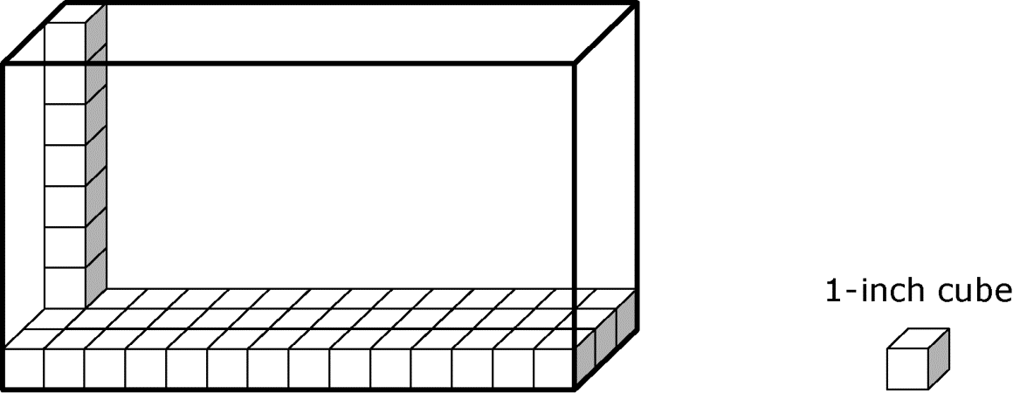

HOT Questions
Jenny said, “I can find the volume of the box by multiplying 6 X 5.” Walter said, “none of the side lengths have 6 as a unit so that is not correct.” What would you say to Walter about Jenny’s reasoning?
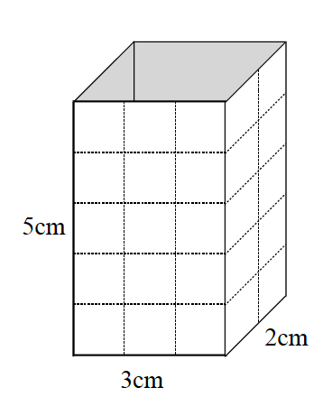

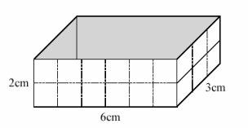
Find the Volume of the box using repeated addition.

Find the volume of the box using the Base X Height

Find the volume of the box using Length X Width X Height

PARCC sample EOY TEST http://practice.parcc.testnav.com/
Number 20
https://www.illustrativemathematics.org/illustrations/1655
https://www.illustrativemathematics.org/illustrations/1308
http://www.insidemathematics.org/assets/common-core-math-tasks/how%20many%20cubes.pdf
http://www.livebinders.com/play/play?present=true&id=1126000
https://grade5commoncoremath.wikispaces.hcpss.org/Assessing+5.MD.5

