Teacher Guide to Clarification

Instructional Math Materials

**5.NF.5a**

**Apply and extend previous understandings of multiplication and division to multiply and divide fractions.**

5.NF.5 Interpret multiplication as scaling (resizing) by:

##### Comparing the size of a product to the size of one factor on the basis of the size of the other factor, without performing the indicated multiplication.

**Without Performing the Indicated Multiplication**

Connect the meaning of multiplication and division of fractions with whole-number multiplication and division. Consider area models of multiplication and both sharing and measuring models for division.

Remember students may believe that multiplication always results in a larger number. Using models when multiplying with fractions will enable students to see that the results will be smaller. Additionally, students may believe that division always results in a smaller number. Using models when dividing with fractions will enable students to see that the results will be larger.

**Example:**

How does the product of 225 x 60 compare to the product of 225 x 30? How do you know? Since 30 is half of 60, the product of 225 x 60 will be double or twice as large as the product of 225 x 30.

× 7 is less than 7 because 7 is multiplied by a factor less than 1 so the product must be less than 7.

7



|  |  |
| --- | --- |
|  |  |

of 7



**Example**: Mrs. Bennett is planting two flowerbeds. The first flowerbed is 5 meters long and 6/5 meters wide. The second flowerbed is 5 meters long and 5/6 meters wide. Which area is larger than 5 square meters? The 5 meters long and 6/5 meters wide area is larger than 5 square meters because you are multiplying by a value larger than one.

**Example:** Is 2 x 8 more or less than 8? 2 x 8 must be more than 8 because 2 groups of 8 is 16 and 2 is almost 3 groups of 8. So the answer must be close to, but less than 24.



**Example:** Is X more or less than



= because multiplying by is the same as multiplying by 1.



Kansas Association of Teachers of Mathematics (KATM) Flipbooks. Questions or to send feedback: [melisa@ksu.edu](mailto:melisa@ksu.edu). Retrieved from: <http://katm.org/wp/wp-content/uploads/flipbooks/5th-Flipbookedited2.pdf>

This Standard connects to Mathematical Practice Standard 7 because students need to see the pattern of multiplication. They need to recognize that when you multiply by a form of one, the value of the number will not change due to the identity property. When multiplying X by a number less than one the product will be less than X and when multiplying X by a number greater than one the product will be greater than X. If students do not recognize this structure, they will not be able to answer questions without performing the multiplication.

**Coherence and Connections: Need to Know**

|  |  |  |
| --- | --- | --- |
| Grade Below | Grade-Level | Grade Above |
| 3.OA.1 3.OA.2 4.OA.1 4.OA.2 4.NF.1 4.MD.2 | **5.NF.5a** 5.NF.3 5.NF.4 5.NF.6 5.OA.2 | 6.RP.1 |

|  |  |  |  |
| --- | --- | --- | --- |
| **Evidence**  **Statement Key** | **Evidence Statement Text** | **Clarifications** | **MP** |
| 5.C.7.1  PBA | Distinguish correct explanation /reasoning from that which is flawed, and – if there is a flaw in the argument – present corrected reasoning. (For example, some flawed ‘student’ reasoning is presented and the task is to correct and improve it.)  Content Scope: Knowledge and skills articulated in 5.NF.5b | None | 3, 7, 8, 6 |
| 5.NF.5a | Interpret multiplication as scaling (resizing), by a. Comparing the size of a product to the size of one factor on the basis of the size of the other factor, without performing the indicated multiplication. | i)In so far as possible, tasks are designed to be completed without performing the indicated multiplication  ii) Products involve at least one factor that is a fraction or mixed number. | 7, 8 |

*PARCC Mathematics Evidence Tables. (*2013, April). Retrieved from:   
 <http://www.parcconline.org/assessment-blueprints-test-specs>

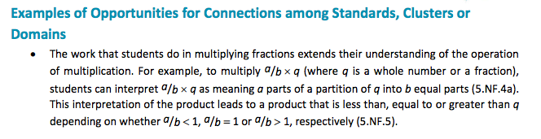

*PARCC Model Content Frameworks: Mathematics Grades 3-11 (version 3)*. (2012, November  
 1). Retrieved June 3, 2014, from <http://parcconline.org/sites/parcc/files/PARCCMCFMathematicsNovember2012V3_FINAL_0.pdf>

**Classroom Resource**

Power Point

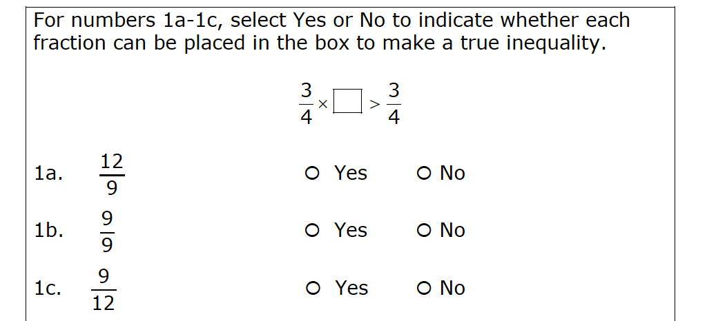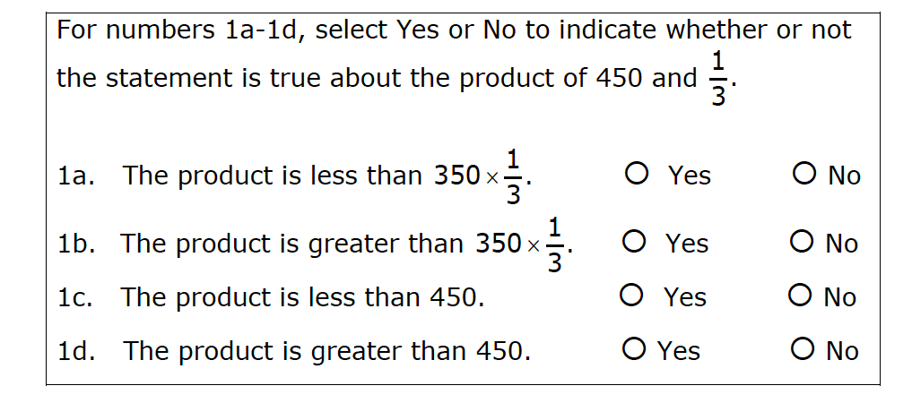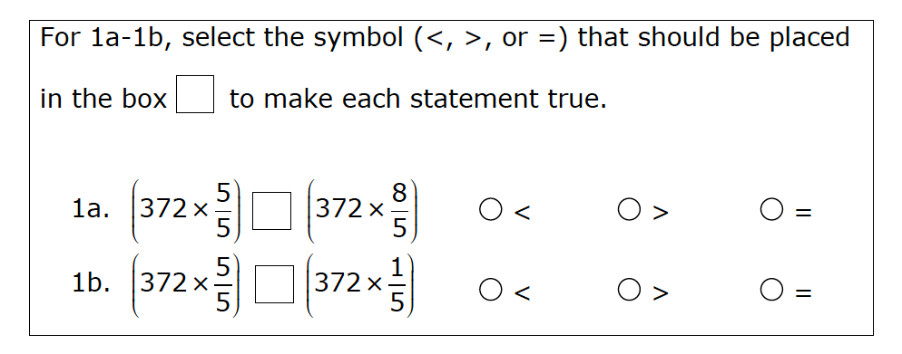

Each day from Monday through Friday, the bakers at Baker’s Square use 1 large sacks of flour to make pie crusts for their awesome pies! Will the bakers use ***more*** or ***less*** than 5 sacks of flour from Monday through Friday? Explain your answer **WITHOUT** solving the problem.

Shiloh wants to make 5 pitchers of tea. Each recipe calls for cup of sugar. If she makes 5  
pitchers of tea will she have more or less than 1 whole cup of sugar? Explain your reasoning.

b. Prove your answer to “a” by calculating the ***total*** number of sacks of flour the bakers

will use from Monday through Friday. Show your work.

Resource From <http://www.smarterbalanced.org/wordpress/wp-content/uploads/2012/05/TaskItemSpecifications/ItemSpecifications/GeneralItemSpecifications.pdf>

**HOT Questions**

1. Which of the following expressions would have a greater product? Explain how you know.

x 18



x 18



______________________________________________________________________________________________________________________________________________________________________________________________________

|  |  |  |
| --- | --- | --- |
|  | • | • |
| n • |  |  |
| • | • | • |

1. Which expressions are equal to N? In words, explain how you decided.

______________________________________________________________________________________________________________________________________________________________________________________________________



PARCC sample EOY TEST <http://practice.parcc.testnav.com/>

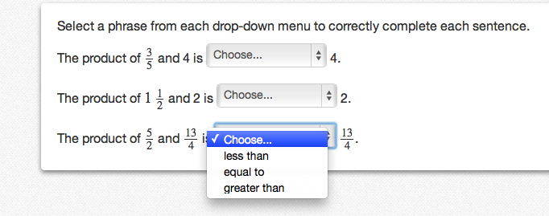

Illustrative Mathematics  
<http://s3.amazonaws.com/illustrativemathematics/illustration_pdfs/000/000/151/original/illustrative_mathematics_151.pdf?1390748916>

<https://www.illustrativemathematics.org/illustrations/150>

<https://www.illustrativemathematics.org/illustrations/151>

<https://www.illustrativemathematics.org/illustrations/164>

<https://www.illustrativemathematics.org/illustrations/143>

New York City Department of Education  
<http://schools.nyc.gov/NR/rdonlyres/B8B8BDAD-2EF2-4BF8-AE93-114C48B563E2/130938/NYCDOEG5Math_TimeforRecess_Final.pdf>