Teacher Guide to Clarification
K.G.4

Analyze, compare, create, and compose shapes
K.G.4 Analyze and compare two- and three-dimensional shapes, in different sizes and orientations, using informal language to describe their similarities, differences, parts (e.g., number of sides and vertices/”corners”) and other attributes (e.g., having sides of equal lengths).
Shapes

It is critical we use proper shape names, even in Kindergarten.

This is a Rhombus. It is NOT a Diamond (there is no shape called a Diamond). It is NOT a Kite (a Kite is a very specific term used later in Mathematics).

This is an Ellipse. It is NOT an oval.

The abilities involved in composing and decomposing shapes are important for many reasons. These geometric competencies are at the foundation of geometry, but also arithmetic (e.g., composing and decomposing numbers and arrays in multiplication), measurement, and higher order geometric work. Creating and then iterating units and higher-order units in the context of construction patterns, measuring, and computing, are established bases for mathematical understanding and analysis.

It is important to allow students to explore and build geometric understanding themselves. One important step to take is to switch from making assertions and generalizations to framing ideas as questions. Rather than saying, “Every time you put two triangles together, you get a square” a mathematically incorrect statement. Ask the following: “How many different ways can you put these two triangles together to make a new shape?” “What shapes will you get?” This allows children to see that even with two right triangles made from a square, they can put these together to make a triangle or a parallelogram.

Kindergartners can develop the ability to intentionally and systematically combine shapes to make new shapes and complete puzzles. They do so with increasing anticipation, on the basis of the shapes’ attributes, and thus, children developmental imagery of the component shapes. They move from using shapes separately to putting them together to make pictures.

A significant advance is that they can combine shapes with different properties, extending the pattern block shapes (whose angles are multiples of 30 degrees) common at early levels to such shapes as tangrams (with angles that are multiples of 45 degrees), and with sets of various shapes that include angles that are multiples of 15 degrees, as well as sections of circles.
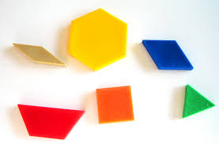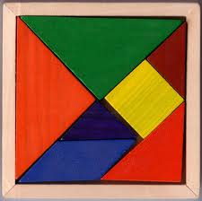
Combining these shape sets should be done after children have worked with the pattern-block shapes separately from the square/rectangle/right triangle shapes based on 90 degrees and 45 degrees because many compositions are possible when the angles are consistent.
Combining shapes connects to K.G.6
Focus in Kindergarten, NCTM 2011

Use shapes collected from students to begin the investigation into basic properties and characteristics of two- and three-dimensional shapes. Have students analyze and compare each shape with other objects in the classroom and describe the similarities and differences between the shapes. Ask students to describe the shapes while the teacher records key descriptive words in common student language. Students may use the word flat to describe two-dimensional shapes and the word solid to describe three-dimensional shapes.

Use the sides, faces and vertices of shapes to practice counting and reinforce the concept of one-to-one correspondence.

The teacher and students orally describe and name the shapes found on a Shape Hunt. Students draw a shape and build it using materials regularly kept in the classroom such as construction paper, clay, wooden sticks or straws.

Students can use a variety of manipulatives and real-world objects to build larger shapes with these and other smaller shapes: squares, circles, triangles, rectangles, hexagons, cubes, cones, cylinders, and spheres. Kindergarteners can manipulate cardboard shapes, paper plates, pattern blocks, tiles, canned food, and other common items.

Have students compose (build) a larger shape using only smaller shapes that have the same size and shape. The sides of the smaller shapes should touch and there should be no gaps or overlaps within the larger shape. For example, use one-inch squares to build a larger square with no gaps or overlaps. Have students also use different shapes to form a larger shape where the sides of the smaller shapes are touching and there are no gaps or overlaps. Ask students to describe the larger shape and the shapes that formed it.

Kansas Association of Teachers of Mathematics (KATM) Flipbooks. Questions or to send feedback: melisa@ksu.edu. Retrieved from: http://katm.org/wp/wp-content/uploads/flipbooks/KFlipBookedited.pdf

Students often tie
orientation to shape!
Students often confuse two- and three-dimension shapes names.
When working with two-dimension shapes make sure the shapes are “flat” or only two-dimensional, like a sheet of paper.

So MIX UP shape
orientation constantly

Coherence and Connections: Need to Know

Levels of geometric thinking
Visual/syncretic Students recognize shapes, e.g., a rectangle “looks like a door”.
Descriptive Students perceive properties of shapes, e.g., a rectangle has four sides, all of its sides are straight, opposite sides have equal length.
Analytic Students characterize shapes by their properties, e.g., a rectangle has opposite sides of equal length and four right angles.
Abstract Students understand that a rectangle is a parallelogram because it has all the properties of parallelograms.

Understanding and describing shapes and space is one of the two critical areas of Kindergarten mathematics.

In the domain of shape, students learn to match two-dimensional shapes even when the shapes have different orientations (K.G.4). They learn to name shapes such as circles, triangles, and squares, whose names occur in everyday language, and distinguish them from non-examples of these categories, often based initially on visual prototypes. For example, they can distinguish the most typical examples of triangles from the obvious non-examples.

From experience with varied examples of shapes, students extend their initial intuitions to increasingly comprehensive and accurate intuitive concept images of each shape category. These richer concept images support students’ ability to perceive a variety of shapes in their environments and describe these shapes in their own words (MP.7). This includes recognizing and informally naming three-dimensional shapes, e.g., “balls”, “boxes”, “cans”. Such learning might also occur in the context of solving problems that arise in construction of block buildings and in drawing pictures, simple maps, and so forth.

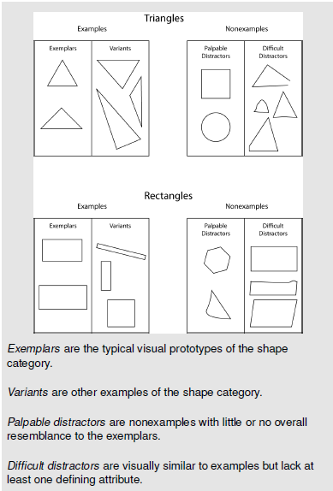 link picture
Teachers should use a variety of “non-examples” to help students have a better understanding of shapes.
Common Core Standards Writing Team. (2013, September 19). Progressions for the Common
Core State Standards in Mathematics(draft). K-6 Geometry. Tucson, AZ: Institute for
Mathematics and Educations, University of Arizona.
Grade-Level | Grade Above
K.G.1  K.G.2  K.G.3  K.G.4 | 1.G.1

K.G.2 and K.G.4 offer some opportunities for counting and comparing numbers.
-PARCC Model Content Frameworks

Classroom Resources

Powerpoint
Tangram Games:
http://www.abcya.com/tangrams.htm
http://pbskids.org/cyberchase/math-games/tanagram-game/
Attribute Blocks Ideas:
http://www.pinterest.com/kreeteacher/pattern-blocks-or-attribute-blocks/
Free Printable Manipulatives (Pattern Blocks):
http://clutterfreeclassroom.blogspot.com/2012/03/free-printable-math-manipulatives.html
Free Online Manipulatives:
http://nlvm.usu.edu/en/nav/category_g_1_t_3.html

HOT Questions

- Which shapes are similar and why? Which shapes are different and why?

- Draw 5 different triangles. How are they the same? How are they different?
- Name 10 items in the classroom and describe them by their shape.
- Draw a picture using AT LEAST 10 different shapes.
- Julie and Amanda are looking at the classroom globe. 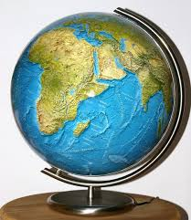
Julie says it is a circle. Amanda says it is a sphere. Who is correct? How do you know?

Additional Resources

Illustrative Mathematics
https://www.illustrativemathematics.org/illustrations/515
Inside Mathematics
http://www.insidemathematics.org/index.php/kindergarten
Hawaii Tasks
http://standardstoolkit.k12.hi.us/comparing-3-d-shapes-k-g-4/
http://standardstoolkit.k12.hi.us/comparing-2-d-and-3-d-shapes-k-g-3k-g-4/
http://standardstoolkit.k12.hi.us/lets-build-2-d-shapes-k-g-4k-g-5/

