Teacher Guide to Clarification
K.OA.2

Understand addition as putting together and adding to, and understand subtraction as taking apart and taking from.
K.OA.2 Solve addition and subtraction word problems, and add and subtract within 10, e.g., by using objects or drawings to represent the problem.
Unknowns

Kindergarten students should be exposed to a variety of addition and subtraction situations. In Kindergarten students are only expected to work with Add to with Result Unknown, Take From with Result Unknown, and Put Together/Take Apart with Total Unknown and Both Addends Unknown. Table 2 below provides examples of each and comes directly from the K, Counting and Cardinality; K-5, Operations and Algebraic Thinking progression document.

Add To Result Unknown
In the past this is the most common situation exposed to students. Students are asked to find the result of adding two given numbers.
Example: Maya has 3 crayons. Her teacher, Ms. Cane, gives her 2 more crayons. How many crayons does Maya have now?
= ?
+

Take Away Result Unknown
In a Take Away Result unknown problem the students are asked to find the result of subtracting two numbers.
Example: Maya has 5 crayons. She broke 3 crayons. How many whole crayons does Maya now have?
= ?
-
Put Together/Take Away Total Unknown
Example: Maya has 5 crayons. Her teacher, Ms. Cane, then gives her 2 more crayons. How many crayons does Maya now have?
= ?
+
Put Together/Take Away Both Addends Unknown
This type of problem relies on students’ understanding of number bonds.
Example: Maya has 8 crayons. If her crayons are only Red or Blue, how many red crayons and how many blue crayons can Maya have?
= ? + ?

Mixing up these situations from the start will help increase students understanding of word problems, equations, numbers, and the equal sign. It is critical to teacher children to understand the meaning and context of word problems so they can solve them correctly. Providing a balanced mix of the above situations will require students from the onset to analyze the context and develop meaning and understanding from the word problems.
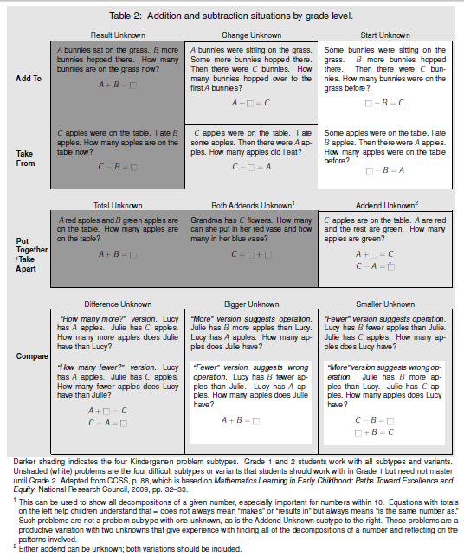
- Link Table
Common Core Standards Writing Team. (2013, September 19). Progressions for the Common
Core State Standards in Mathematics(draft). K-5 Counting and Cardinality and
Operations and Algebraic Thinking. Tucson, AZ: Institute for Mathematics and
Educations, University of Arizona.

“What is the fundamental message that kids get when told to look for the key/clue word? Don’t read the problem. Don’t imagine the situation. Ignore the context. Abandon your prior knowledge….You don’t have to read; you don’t have to think. Just grab the numbers and compute.”
Hyde, Comprehending Math, 2006

Coherence and Connections: Need to Know

“Students develop meanings for addition and subtraction as they encounter problem situations in Kindergarten, and they extend these meanings as they encounter increasingly difficult problem situations in Grade 1. They represent these problems in increasingly sophisticated ways. And they learn and use increasingly sophisticated computation methods to find answers. In each grade, the situations, representations, and methods are calibrated to be coherent and to foster growth from one grade to the next.”
Common Core Standards Writing Team. (2013, September 19). Progressions for the Common
Core State Standards in Mathematics(draft). K-5 Counting and Cardinality and
Operations and Algebraic Thinking. Tucson, AZ: Institute for Mathematics and
Educations, University of Arizona.
Students will work with problems including Change Unknown and Start Unknown in First grade, building on what they have learned in Kindergarten.
K.OA.2 is connected directly to:
K.OA.1 Represent addition and subtraction with objects, fingers, mental images, drawings, sounds (e.g., claps), acting out situations, verbal explanations, expressions or equations.
K.OA.5 Fluently add and subtract within 5.
“Through representing and solving addition and subtraction problems, students understand addition as joining and adding to and understand subtraction as separating and taking from. Initially, the meaning of addition is separate from the meaning of subtraction, and students build relationships between addition and subtraction over time, with subtraction coming to be understood as reversing the actions involved in addition and as finding an unknown addend.”
PARCC Draft Model Content Frameworks: Mathematics Grades K-2 (2013, December).
Retrieved May 10, 2014, from http://parcconline.org/sites/parcc/files/PARCCMCFMathematicsNovember2012V3_FINAL_0.pdf
Grade-Level | Grade Above
K.OA.1  K.OA.2  k.OA.3 | 1.OA.1  1.OA.3  1.OA.4  1.OA.6

Classroom Resources

Powerpoint
Differentiation: Allow struggling students to work with numbers equal to or less than 5. Have them build up to using numbers equal to or less than 10.

HOT Questions

- Have students create their own one-step word problem (Teacher may need to write the equation for them) including a drawing. Have them create one for addition and one for subtraction.
- Liam brought 9 cupcakes to school. If his mom made some vanilla cupcakes and some chocolate cupcakes, how many of each (vanilla and chocolate) could Liam have brought to school? Draw a picture to prove your answer.
- Kelsey said, “All addition problems have the word more in them. That’s how you know to add.” Bobby disagrees with Kelsey. He said, “Sometimes the word more is part of an addition problem but not always.” Who is correct and why? Provide an addition problem that supports your decision.
Additional Resources

Illustrative Mathematics
http://www.illustrativemathematics.org/illustrations/70
http://www.illustrativemathematics.org/illustrations/1224
http://www.illustrativemathematics.org/illustrations/1405
Inside Mathematics
http://www.insidemathematics.org/index.php/kindergarten
Hawaii Tasks
http://standardstoolkit.k12.hi.us/bananas/
http://standardstoolkit.k12.hi.us/apples-k-oa-1k-oa-2/

