Teacher Guide to Clarification
K.OA.4

Understand addition as putting together and adding to, and understand subtraction as taking apart and taking from.
K.OA.4 For any number from 1 to 9, find the number that makes 10 when added to the given number, e.g., by using objects or drawings, and record the answer with a drawing or equation.
Importance of 10

Students naturally develop benchmark numbers of five and ten, fingers on one hand and fingers on two hands. It is helpful to continue this concept by reiterating number sense based on 5’s and 10’s. This can be done with ten-frames and rekenraks.
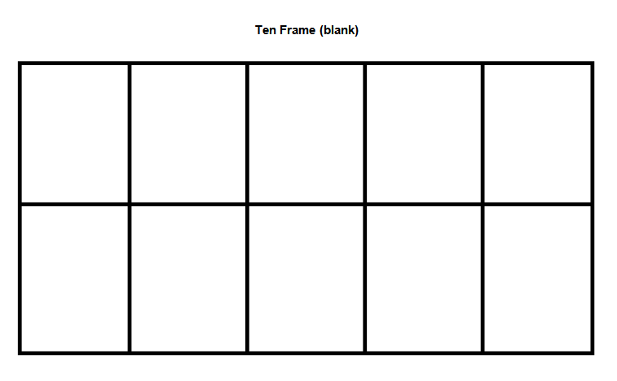
For some great ideas: http://www.pinterest.com/jennykaysmith/math-five-frames-ten-frames/
http://www.k-5mathteachingresources.com/ten-frames.html
http://www.pinterest.com/drnicki7/rekenrek/
http://www.ilclassroomsinaction.org/balanced-assessment.html
Free printable templates (ten frames): http://lrt.ednet.ns.ca/PD/BLM/table_of_contents.htm
A free Rekenrek program from Sharon Rak
“Development of the numbers 1 through 5 is principally done through sight recognition of patterns, coupled with immediate association with the oral name and written symbol. It is important to provide different configurations of dots, blocks, and other objects, as well as different forms of the numerals to broaden their experiences. (Example: 4 and 4).
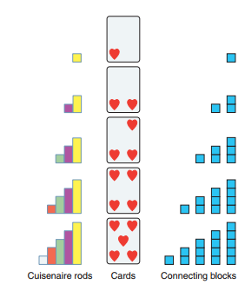
The number 10 is composed of two groups of 5. The number 10 provides the cornerstone for our number system. A ten-frame is certainly one of the most effective models for facilitating patterns, developing group recognition of numbers, and building an understanding of place value. This frame is a powerful organizer and helps provide the base for many thinking strategies and mental computation.”
http://www.wiley.com/college/sc/reys/ch07.pdf
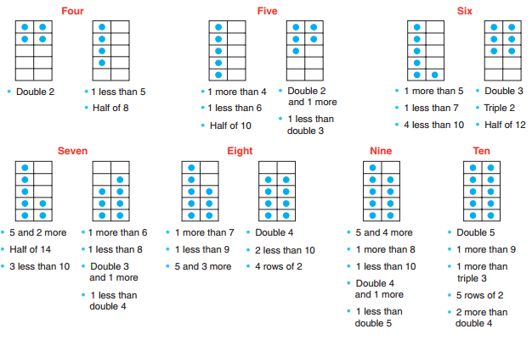
Ten Frames are demonstrating different ways to show the numbers on the ten-frames. You are not asking kids to use these strategies for this standard. It it beneficial to mix up the ways you mark in ten-frames.

“The number pairs that total ten are foundational for students’ ability to work fluently within numbers and operations. Once students have experience breaking apart ten in various combinations, this asks students to find the missing part of ten.
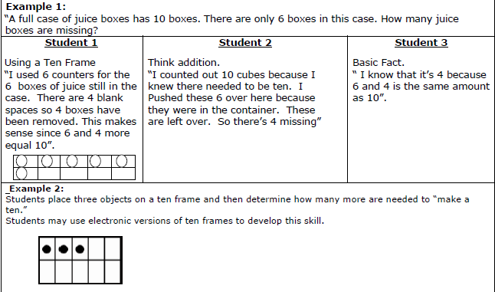
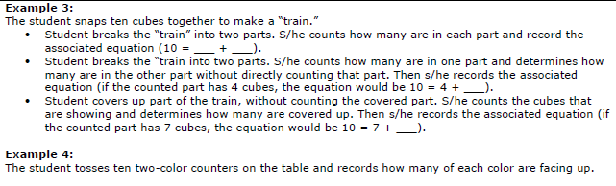
Kansas Association of Teachers of Mathematics (KATM) Flipbooks. Questions or to send feedback: melisa@ksu.edu. Retrieved from: http://katm.org/wp/wp-content/uploads/flipbooks/KFlipBookedited.pdf

Coherence and Connections: Need to Know

K.OA.4 is closely tied to K.OA.3 – Decompose numbers less than or equal to 10 into pairs in more than one way, and K.OA.1 – Represent addition and subtraction with objects, fingers, mental images, drawings, sounds (e.g., claps), acting out situations, verbal explanations, expressions or equations.
Students expand their work in addition and subtraction from within 5 to within 10. They use the Level 1 methods developed for smaller totals as they represent and solve problems with objects, their fingers, and math drawings. Patterns such as the 5+n pattern used widely around the world play an important role learning particular additions and subtractions, and later as patterns in steps in the Level 2 and 3 methods. Fingers can be used to show the same 5 patterns, but students should be asked to explain these relationships explicitly because they may not be obvious to all students (MP.3). As the school year progresses, students internalize their external representations and solution actions, and mental images become important in problem representation and solution.
Common Core Standards Writing Team. (2013, September 19). Progressions for the Common
Core State Standards in Mathematics(draft). K-5 Counting and Cardinality and
Operations and Algebraic Thinking. Tucson, AZ: Institute for Mathematics and
Educations, University of Arizona.
“”Making ten” will become a key strategy (in grade 1) for adding and subtracting within 20; students gain the foundation for this in kindergarten by finding the number that makes 10 when given another number. Over the course of the year, given frequent opportunities (e.g., a “how many fingers don’t you see” game), many kindergarten children can become fluent with the pairs of numbers that make 10 and can, when a number less that 10 is named, name the “missing amount” even without looking at fingers.”
PARCC Draft Model Content Frameworks: Mathematics Grades K-2 (2013, December).
Retrieved May 10, 2014, from http://parcconline.org/sites/parcc/files/PARCCMCFMathematicsNovember2012V3_FINAL_0.pdf
Grade-Level | Grade Above
K.OA.3  K.OA.4 | 1.OA.6

Classroom Resources

Powerpoint

HOT Questions

- A full package of markers has 10 markers. There are 7 markers in the package. How many are missing?
- Nora says eight and two together equal ten. Is Nora correct? Draw a picture to illustrate your reasoning.
- The teacher can call out a number less than 10 and have the class hold up (on ten frames, fingers, rekenrek, etc.) what the missing number is to equal 10.

Additional Resources

Inside Mathematics
http://www.insidemathematics.org/problems-of-the-month/pom-gotyournumber.pdf
Hawaii Tasks
http://standardstoolkit.k12.hi.us/make-10-with-a-ten-frame-k-oa-4/
Facts of Ten Activity
http://www.k-5mathteachingresources.com/support-files/factsoften.pdf

