Teacher Guide to Clarification

Instructional Math Materials

5.NBT.6

Perform operations with multi-digit whole numbers and with decimals to hundredths.

5.NBT.6 Find whole-number quotients of whole numbers with up to four-digit dividends and two-digit divisors, using strategies based on place value, the properties of operations, and/or the relationship between multiplication and division. Illustrate and explain the calculation by using equations, rectangular arrays, and/or area models.
Quotients Based on Strategies

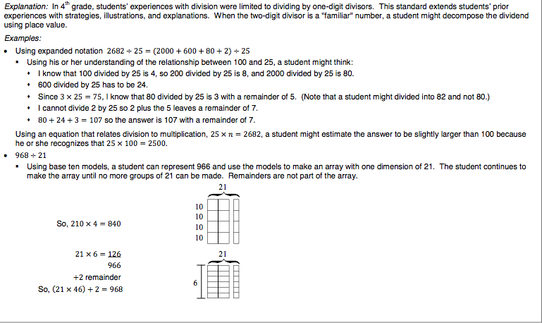
Note how equations are used based on the drawing or model. Students need to develop the ability to create equations from their drawings or models.
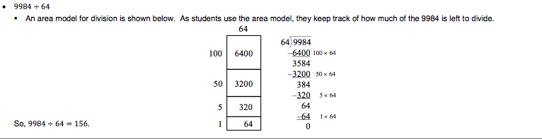
www.doe.k12.de.us/aab/Mathematics/Mathematics_docs_folder/DE_CCSS_Grade5.pdf

Sample Problems:
David does the same number of pulls-ups each day. If he did 3,813 pull-ups in 31 days, how many pulls-up did he do each day?
Relationship Between Multiplication and Division
Catherine solved the problem, 3,813 ÷ 31 = 123, and thought her answer was incorrect.
What multiplication equation can she use to check her work?
3,813 = 31 x 123

Area Model

3,813 ÷ 31 = 123

100 + 20 + 3
31  3100 | 620 | 93
Coherence and Connections: Need to Know

Grade Below | Grade-Level | Grade Above
4.NBT.4  4.NBT.6 | 5.NBT.6  5.NBT.1  5.NBT.5  5.NBT.7 | 6.NS.2  6.NS.3
PARCC PBA and EOY
Evidence  Statement Key | Evidence Statement Text | Clarifications | MP
5.C.1.1 | Base explanations/reasoning on the properties of operations. Content Scope: Knowledge and skills articulated in 5.NBT.6 | i) Students need not use technical terms such as commutative, associative, distributive, or property.  ii) Tasks do not have a context. | 3, 7, 5, 6
5.C.2.1 | Base explanation/reasoning on the relationship between addition and subtraction or the relationship between multiplication and division.  Content Scope: Knowledge and skills articulated in 5.NTB.6 | None | 3, 7, 5, 6
5.C.4.3 | Base arithmetic explanations/reasoning on concrete referents such as diagrams (whether provided in the prompt or constructed by the student in her response), connecting the diagrams to a written (symbolic) method.  Content Scope: Knowledge and skills articulated in 5.NBT.6 | None | 3, 5, 6
EOY  5.NBT.6 | Find whole-number quotients of whole numbers with up to four-digit dividends and two-digit divisors, using strategies based on place value, the properties of operations, and/or the relationship between multiplication and division. Illustrate and explain the calculation by using equations, rectangular arrays, and/or area models. | i) Tasks do not require students to illustrate or explain.  ii) Tasks involve 3- or 4-digit dividends and one- or two-digit divisors. | 1,5
PARCC Mathematics Evidence Tables. (2013, April). Retrieved from:
http://www.parcconline.org/assessment-blueprints-test-specs

Examples of Opportunities for In-Depth Focus
5.NBT.6 The extension from one-digit divisors to two-digit divisors requires care. This is a major milestone along the way to reaching fluency with the standard algorithm in grade 6 (6.NS.2).
Examples of Opportunities for Connecting Mathematical Content and Mathematical Practices
Mathematical practices should be evident throughout mathematics instruction and connected to all of the content areas highlighted above, as well as all other content areas addressed at this grade level. Mathematical tasks (short, long, scaffolded, and unscaffolded) are an important opportunity to connect content and practices. Some brief examples of how the content of this grade might be connected to the practices follow. When students break divisors and dividends into sums of multiples of base-ten units (5.NBT.6), they are seeing and making use of structure (MP.7) and attending to precision (MP.6). Initially for most students, multidigit division problems take time and effort, so they also require perseverance (MP.1) and looking for and expressing regularity in repeated reasoning (MP.8).
PARCC Model Content Frameworks: Mathematics Grades 3-11 (version 3). (2012, November
1). Retrieved June 3, 2014, from http://parcconline.org/sites/parcc/files/PARCCMCFMathematicsNovember2012V3_FINAL_0.pdf
Classroom Resource

PowerPoint
ISBE Model Math Curriculum Grade 5 Unit 1
http://www.livebinders.com/media/get/OTA3MTgyMw==
http://www.livebinders.com/media/get/OTA3MTgzNA==
http://www.livebinders.com/media/get/OTA3MTg0MA==
http://www.livebinders.com/media/get/OTA3MTkwMA==
http://www.livebinders.com/media/get/OTA3MTk2Nw==
At Maria’s school, 6 classes are going on a field trip. Each class has 26 students and 1 teacher. Each bus holds a maximum of 48 people. The school requests 3 buses for the field trip. Read Maria’s argument below. Circle the statement in Maria’s argument that has incorrect reasoning or inaccurate calculations. Then correct the statement.
a. Maria says that 3 buses are not enough.
b. She argues that 3 buses will hold a maximum of 144 people.
c. The classes need space for 156 people.
d. The school needs to order 1 more bus.
Resource: Smarter Balanced Assessment Consortium Practice test Grade 5, 2013

HOT Questions

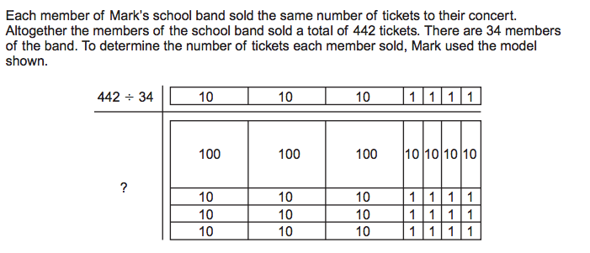
How many tickets did each member of Mark’s school band sell?
http://www.louisianabelieves.com/docs/assessment/practice-test-math-grade-5.pdf?sfvrsn=4

Use the digits 1, 2, 5, 7 and 9 each once to create the largest quotient

$÷$

Deb solved 585 ÷ 45 with this area model but she doesn’t know the solution. Explain to her how to get the answer form her work.
450 | 90 | 45

45
10
2
585
- 450
135

135
- 90
45

1
45
- 45
0

Select all the equations that will solve 4525 ÷ 25. Let n equal the quotient.

- n ÷ 25 = 4525
- n ÷ 4535 = 25
- 4525 ÷ 25 = n
- 25 ÷4525 = n
- 25 x 4525 = n
- 4525 = n x 25
- 25 x n = 4525
- 4525 = n
25

PARCC sample EOY TEST http://practice.parcc.testnav.com/
Number 27
Illustrative Mathematics
https://www.illustrativemathematics.org/illustrations/878
Howard County Wikispace
https://grade5commoncoremath.wikispaces.hcpss.org/Assessing+5.NBT.6
Robert Kaplinsky
http://robertkaplinsky.com/work/prison-escape/
Teresa Emmert
http://teresaemmert.weebly.com/uploads/1/3/0/5/13053448/division_and_interpreting_remainders_grade_5_revised_august_5th_2012.pdf
K-5 Teaching Resources
http://www.k-5mathteachingresources.com/support-files/division-strategy-partial-quotients-ver.3.pdf
http://www.k-5mathteachingresources.com/support-files/division-strategy-partition-the-dividend-ver.2.pdf
http://www.k-5mathteachingresources.com/support-files/division-strategy-multiplying-up.pdf
http://www.k-5mathteachingresources.com/support-files/write-it-solve-it-check-it-ver.3.pdf
Learnzillion
https://learnzillion.com/lessons/551
https://learnzillion.com/lessons/553
https://learnzillion.com/lessons/552

